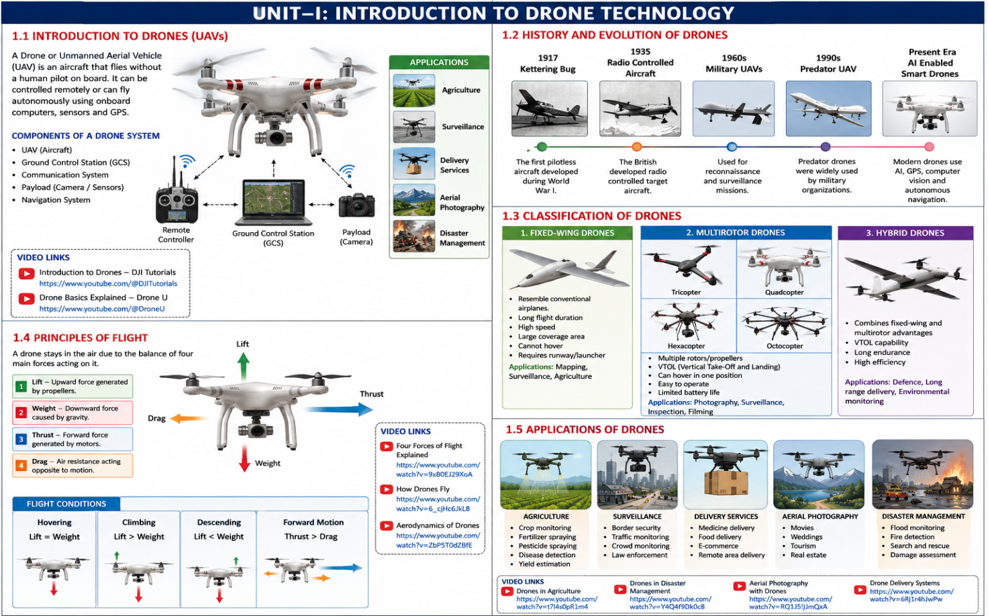

CHAPTER 1

INTRODUCTION

1.1INTRODUCTIONTODRONES
The term drones covers a very broad category of unmanned aerial vehicles (UAVS) that can be used for anything from military or commercial purposes, to personal entertainment. In popular culture, when people talk about drones they are frequently referring to any of a range of quad copters that have become trendy over the last two years.
Unlike regular helicopters, quad copters have two sets of propellers, making them easier to handle both indoors and outdoors. Modern quad copters have begun in corporation arrange of new technology, including electronic sensors that stabilize them, with some models even controllable via a smart phone app instead of bulky controllers. Some models can even be programmed to fly set paths or patterns.
1.2 HISTORY OPF DRONE:

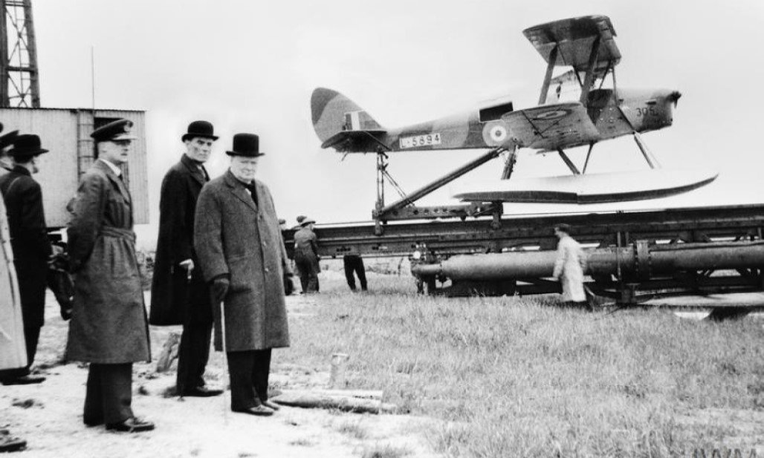

History of Drone Technology: An Overview of the Latest Advancements and Innovations
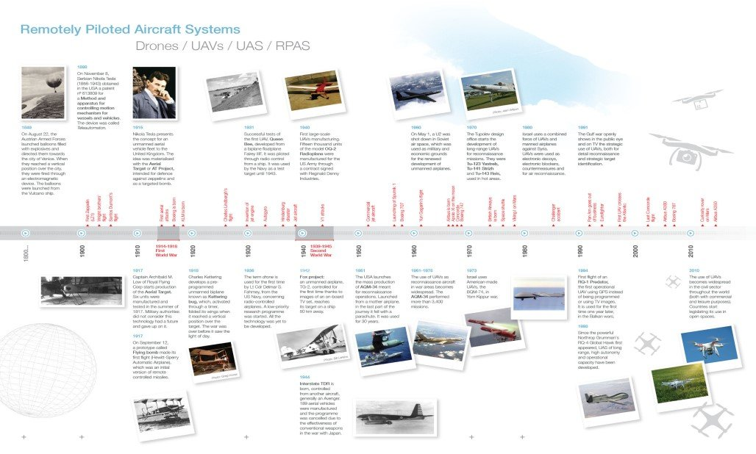

Introduction to Drone Technology
Drones, also known as unmanned aerial vehicles (UAVs), have transformed the way industries operate, military strategies unfold, and consumers engage with new technologies. These flying machines, which operate without a human pilot onboard, have experienced rapid technological advancements over the years, evolving from rudimentary devices to sophisticated tools that can handle complex tasks autonomously. Their role has expanded from military reconnaissance missions to revolutionizing fields like agriculture, healthcare, logistics, and entertainment. Understanding the history of drone technology helps in appreciating its current innovations and imagining the future possibilities.

Early History of Drone Technology
The origins of drones trace back to the early 20th century when nations began experimenting with unmanned aircraft for military purposes. These early devices were rudimentary, often unreliable, and primarily used as target practice for training fighter pilots. The concept of UAVs during this period was not widely adopted beyond this basic use case.
During World War I, the development of the first operational drones began. These early designs, such as the Kettering Bug, were designed to act as “flying bombs,” meant to deliver explosives over enemy lines. However, their unreliability and lack of precision made them impractical for widespread use. The advancements in drone technology during World War II were more significant, with further development in remote-controlled devices like the radio-controlled aircraft used for target practice and surveillance.

The Cold War Era and Drones:
The Cold War period marked a major turning point in drone development. Both the United States and the Soviet Union recognized the value of UAVs for surveillance, reconnaissance, and intelligence gathering. During this era, drones became increasingly sophisticated, capable of longer flights and enhanced accuracy. The development of the Ryan Model 147 Lightning Bug by the U.S. during the Vietnam War is one example of a drone used for reconnaissance purposes, showcasing the growing reliance on unmanned vehicles in military operations.
This era also saw early interest in commercial drone applications, although their use outside of military contexts remained limited due to technological and regulatory challenges.

Drone Technology in the 21st Century
The 21st century brought about a significant evolution of drones from strictly military devices to versatile tools in various commercial and consumer markets. The use of drones expanded rapidly across sectors such as entertainment, filmmaking, and aerial photography. Innovations in camera technology, GPS, and battery life fueled this growth, making drones more accessible and user-friendly for the general public.
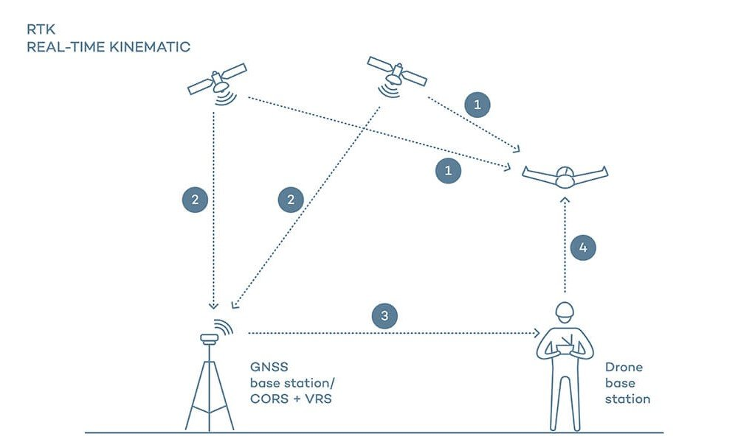
Source: https://wingtra.com/ppk-drones-vs-rtk-drones/
Consumer drones, led by companies like DJI, became popular for capturing breathtaking aerial footage, leading to new ways of storytelling in the film and media industry. The rise of drone hobbyists also contributed to an increased demand for affordable and easy-to-operate drones.
Simultaneously, government bodies worldwide began implementing regulations to manage the widespread use of drones, ensuring safety, privacy, and airspace management.

Latest Advancements in Drone Technology
Recent advancements in drone technology have focused on improving autonomy, intelligence, and endurance. Autonomous drones are capable of operating with minimal human intervention, thanks to advances in artificial intelligence (AI). AI allows drones to make real-time decisions, navigate complex environments, and perform tasks like object recognition and obstacle avoidance.
Swarming technology is another significant innovation, enabling multiple drones to work together in a coordinated manner. This has applications in military operations, search and rescue missions, and entertainment, such as synchronized drone light shows.
Drones are also benefiting from advancements in battery technology, with longer flight times and more efficient energy consumption. Innovations like hydrogen fuel cells and solar-powered drones are pushing the boundaries of what drones can achieve in terms of endurance.
One of the most anticipated advancements is the use of drones in delivery systems. Companies like Amazon and UPS are testing drone delivery programs to speed up the delivery process and reduce logistical costs, especially in rural or hard-to-reach areas.

Innovations in Drone Applications
Beyond military and commercial uses, drones are making a profound impact across various industries. In agriculture, drones are being used for precision farming, where they help monitor crop health, assess soil conditions, and even apply pesticides more efficiently. This technology enables farmers to manage their fields more effectively, leading to increased yields and reduced costs.
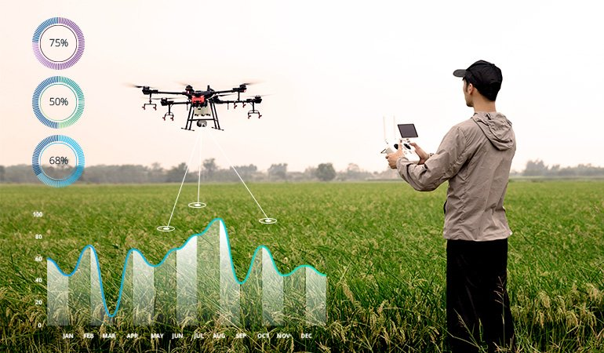
In environmental conservation, drones are invaluable for monitoring wildlife populations, tracking deforestation, and mapping ecosystems in ways that are less intrusive than traditional methods. Conservationists can use drones to gather crucial data while minimizing human impact on fragile environments.
Healthcare is another area where drones are making a difference. Drones are being deployed to deliver medical supplies, vaccines, and even blood samples to remote or disaster-stricken areas. In regions where infrastructure is lacking, drones can provide life-saving support quickly and efficiently.

AI and Machine Learning in Drones
The integration of AI and machine learning into drones has significantly enhanced their capabilities. AI allows drones to process vast amounts of data in real time, making them more effective in tasks like object recognition, obstacle detection, and autonomous navigation. Drones equipped with AI can scan and analyze large areas quickly, identifying patterns and anomalies that would take humans much longer to detect.
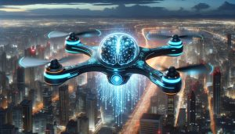
Machine learning algorithms help drones improve over time, learning from previous flights to optimize their performance. This is particularly important for predictive maintenance, where drones monitor their own condition and report issues before they become critical, reducing downtime and repair costs.

The Role of 5G in Drone Technology
The advent of 5G networks is transforming drone technology by enabling faster, more reliable communication between drones and control centers. 5G’s high-speed data transmission allows for real-time video streaming, improving the accuracy of remote operations.
In addition, 5G enhances long-distance control of drones, enabling them to operate in areas that are beyond the line of sight of their operators. This opens up new possibilities for drone delivery services, remote surveillance, and even urban air mobility systems like drone taxis.
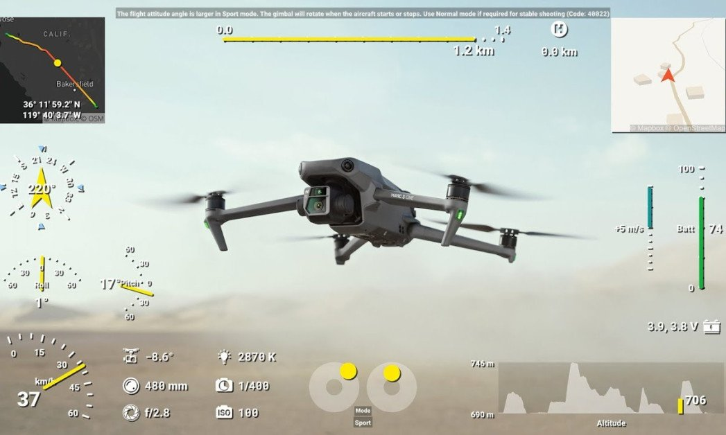

Drone Laws and Regulatory Challenges
The widespread adoption of drone technology has necessitated the development of regulatory frameworks to ensure safety, privacy, and proper airspace management. Globally, drone laws vary, with some countries encouraging drone use while others impose strict restrictions.
In the United States, the Federal Aviation Administration (FAA) plays a key role in regulating drone operations. The FAA’s Part 107 regulations outline the rules for commercial drone pilots, including requirements for licensing, operational limits, and no-fly zones. These rules are crucial for maintaining safety, especially as the skies become increasingly crowded with both manned and unmanned aircraft.

Internationally, regulations differ widely. In the European Union, for example, the European Union Aviation Safety Agency (EASA) implements a unified framework across member states. China, a major player in drone manufacturing and usage, has its own set of guidelines managed by the Civil Aviation Administration of China (CAAC).
Despite these regulations, challenges remain. One significant issue is privacy, as drones can capture images and data without the knowledge of those being filmed. This has led to concerns about surveillance and data security, especially in urban areas where drones may inadvertently record sensitive information. As a result, many countries are working on balancing the benefits of drones with privacy protections.
In addition to privacy concerns, airspace management poses another challenge. Low-altitude air traffic management systems are being developed to safely integrate drones into national airspace alongside traditional aircraft. These systems will need to address collision avoidance, real-time communication, and the safe operation of multiple drones in congested environments.

Commercial Drone Services
One of the most rapidly expanding sectors in the drone industry is commercial services. Drones are now employed in various industries for tasks that were once time-consuming, dangerous, or impossible to complete with traditional methods.
Aerial photography and cinematography are among the most popular commercial applications of drones. Drones equipped with high-resolution cameras allow filmmakers, photographers, and marketers to capture stunning, panoramic views from the sky. This has revolutionized industries like real estate, where aerial footage of properties is now commonplace, as well as tourism and advertising.
In addition to photography, drones are widely used for mapping and surveying. Using LiDAR (Light Detection and Ranging) technology, drones can generate highly accurate 3D maps and models of large areas. This is particularly useful in construction, mining, and land development, where surveying the terrain is essential for planning and resource management.
Another critical commercial application is infrastructure inspection. Drones are deployed to inspect bridges, pipelines, power lines, and wind turbines. They can reach difficult-to-access areas, reducing the need for human workers to engage in potentially hazardous tasks. This not only increases safety but also allows for quicker, more cost-effective inspections.

Drones in the Defense Industry
While drones are now prevalent in commercial sectors, their origins are firmly rooted in military applications, and they continue to play a crucial role in defense strategies worldwide. Unmanned Combat Aerial Vehicles (UCAVs), which are weapon zed drones, have become a central component of modern military operations.
Drones in the military are used for several purposes, including intelligence gathering, surveillance, reconnaissance, and combat missions. These drones can operate in hostile environments where it would be too risky to send human pilots. One example is the U.S. MQ-9 Reaper, a drone capable of carrying out precision airstrikes while also gathering real-time intelligence.
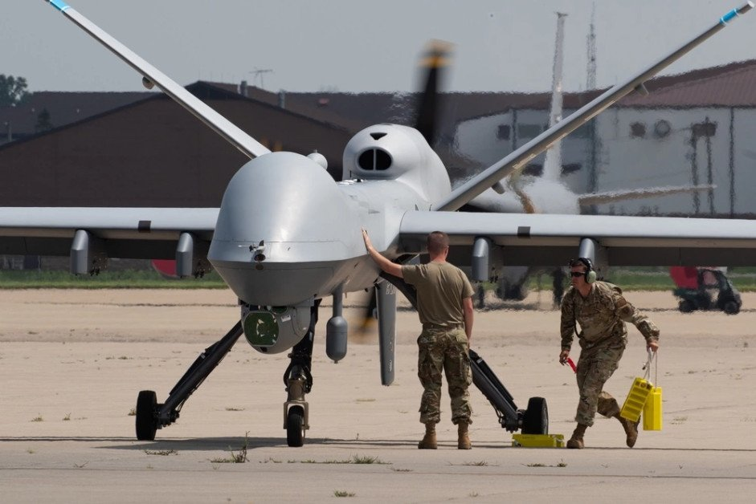
The use of drones in military operations raises several ethical and legal issues. The increasing autonomy of drones, coupled with their use in combat situations, has sparked debates over autonomous weapons systems and the implications for international law and warfare ethics. While drones reduce the risk to military personnel, they also raise concerns about accountability and the potential for unintended civilian casualties.
Despite these challenges, the defense sector continues to invest heavily in drone technology, developing more advanced autonomous systems that can operate with minimal human oversight.

Environmental Impact of Drone Technology
Drones offer several environmental benefits, particularly in industries such as agriculture, conservation, and infrastructure. However, like all technologies, they also come with their own set of environmental challenges.
On the positive side, drones can significantly reduce the environmental footprint of certain operations. In agriculture, for example, drones help farmers optimize the use of resources like water and fertilizers, leading to more efficient farming practices and less waste. Drones can monitor crops, assess soil health, and even apply pesticides with pinpoint accuracy, reducing the amount of chemicals that enter the environment.

In environmental conservation, drones are used to monitor wildlife populations, track illegal logging, and survey endangered habitats. They provide a non-intrusive way to gather data over large areas, helping researchers and conservationists protect ecosystems and biodiversity.
Ecological monitoring via drones has become a powerful tool in tracking the health of forests, coral reefs, and other natural habitats. Drones equipped with thermal imaging cameras can track species’ movements, monitor deforestation rates, and even detect poaching activities in protected areas.
Despite these benefits, drones also have potential environmental downsides. Noise pollution is one concern, particularly when drones are used in large numbers in populated areas. Drones can disturb wildlife, especially in sensitive ecosystems where noise or the presence of foreign objects can disrupt natural behaviors.
There are also concerns about the energy consumption of drones, especially those powered by traditional lithium-ion batteries. While advancements are being made in drone efficiency, the environmental impact of battery production and disposal remains an issue.

Future Trends in Drone Technology
As drone technology continues to evolve, several exciting trends are shaping the future of the industry.
One such trend is the miniaturization of drones. Smaller, more compact drones are being developed for specialized tasks, such as indoor inspections, surveillance, and even medical purposes like delivering supplies within hospitals. These micro drones can navigate confined spaces, making them ideal for urban environments or areas with complex infrastructures.

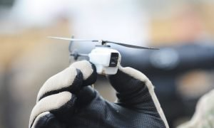
Another significant trend is the integration of drones into smart city infrastructure. In the future, drones could play a key role in urban management, from monitoring traffic and pollution levels to delivering goods and services efficiently. Drones equipped with sensors could also help in maintaining public safety by detecting hazards or responding to emergencies.
Perhaps one of the most futuristic developments is the concept of drone taxis and urban air mobility. Companies like Volocopter and Uber Elevate are working on aerial transportation systems that could carry passengers across cities, reducing congestion on roads. While this concept is still in the experimental stage, advancements in battery life, AI, and flight control systems are bringing the vision of airborne public transport closer to reality.3

Challenges Facing the Drone Industry
Despite the rapid advancements in drone technology, several challenges remain that could affect the future growth of the industry.
One major technical hurdle is battery life. While improvements are being made, most drones still have limited flight times due to the constraints of current battery technology. Extending flight endurance is crucial for applications like long-distance deliveries and large-scale surveying.
Payload capacity is another challenge. Many drones are limited in the weight they can carry, restricting their use in industries that require heavy-lifting capabilities. Advances in lightweight materials and more powerful motors could address this limitation, but it remains an obstacle for widespread adoption in logistics and other fields.
Navigation in GPS-denied environments also poses a challenge for drones. While GPS is critical for drone navigation, it is unreliable or unavailable in certain environments, such as dense urban areas, underground, or indoors. Developing alternative navigation systems, such as computer vision or inertial navigation systems, is a priority for expanding drone operations.
In addition to technical challenges, the industry faces regulatory hurdles. As drone use expands, particularly in commercial sectors, ensuring compliance with local and international laws becomes more complex. Navigating these regulations, especially for businesses operating across borders, can be a time-consuming and expensive process.
Finally, ethical concerns around the use of drones, especially in surveillance and military applications, continue to spark debate. The increasing autonomy of drones raises questions about accountability, privacy, and the potential misuse of technology in both civilian and defense contexts.

Economic Impact of Drone Technology
The economic impact of drone technology is profound, with the industry experiencing rapid growth across multiple sectors. Job creation is one of the most visible effects, with opportunities arising in drone manufacturing, software development, and operations. Additionally, pilot training and drone maintenance services have become essential as more businesses adopt drone solutions.
Industries like logistics, agriculture, construction, and entertainment are seeing substantial cost savings and efficiency gains through the adoption of drone technology. For example, the ability to inspect infrastructure remotely, without the need for human labor or costly machinery, can result in significant financial benefits for companies.
The growing use of drones in delivery services, particularly in rural areas or during emergencies, has the potential to transform the logistics industry by cutting delivery times and lowering costs. Companies investing in drone fleets are exploring innovative ways to integrate drones into their supply chains, from last-mile delivery solutions to warehouse management.

1.3 TYPES OF DRONE:

What are the different types of drones and their uses?
Drones come in different sizes, capabilities, and a wide variety of models, from recreational mini-drones to control and surveillance drones. Instead of throwing a bunch of new information at you, we decided to break things down into a few different drone categories.

Types of drones according to wing types
Drone type | Advantage | Disadvantage | Use
Multi-rotor drones | - Easy to control and maneuver  - VTOL and hover flight  - Often lower price  - Portability | - Limited flying time  - Small payload capabilities  - Less stability in the wind  - Lower flight speeds | - Aerial photography  - Aerial inspection  - Landing surveying  - Agriculture
Fixed-wing drones | - Longer flight time  - Can carry a heavier payload  - Greater stability in the wind  - Higher flight speeds | - More training needed  - No VTOL/hover  - Expensive  - Difficult to land, more places needed | - Aerial mapping  - Utility inspection  - Surveillance  - Agriculture
Single-rotor helicopter drones | - VTOL and hover flight  - Long endurance (with gas power)  - Heavier payload capability | - More dangerous  - Harder to fly, more training needed  - Expensive | - Aerial LiDAR laser scanning
Fixed-wing hybrid VTOL drones | - VTOL and hover  - Long-endurance flight  - Fast speed  - Heavier payload capability | - More training needed  - Expensive | - Aerial mapping  - Utility inspection  - Surveillance  - Agriculture  - Search and rescue
Here is a rundown of the four main types of drones according to wing type, their uses, their advantages, and disadvantages：
Multi-rotor drones
Multi-rotor drones, also known as rotary-wing, are the most widely used type of drones for recreational and professional use. Their small size and excellent control make multi-rotor drones the best choice for aerial photography.
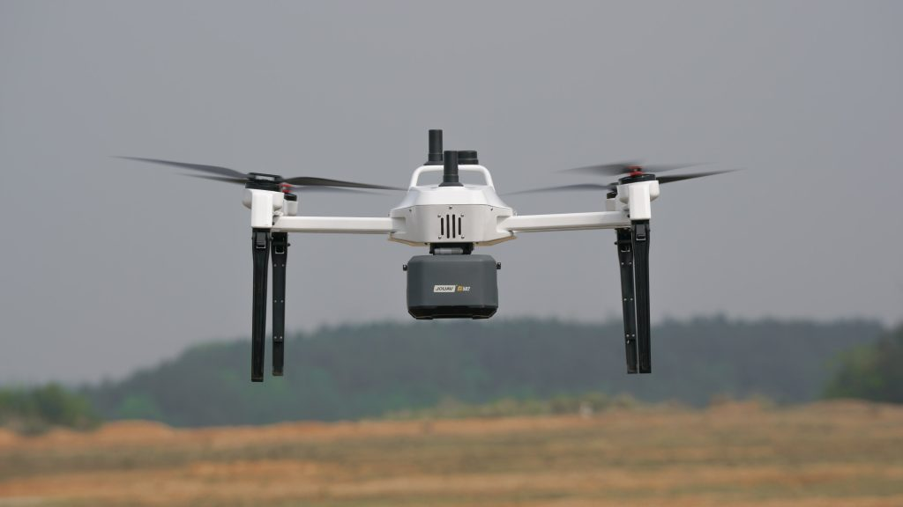
Offering great versatility, they allow the installation of all types of cameras to perform different tasks. They are drones that can hover easily and take off vertically, adding more flexibility as well.
However, the biggest drawback of multi-rotor drones is usually related to the flight autonomy they offer. Adding more rotors makes the drone more difficult to control. All those moving parts also consume extra energy, draining the battery faster. Most multi-rotor drones have a flight time of less than an hour. If we want to perform certain tasks that take a long time, we have to have several batteries to replace them. This also means extra costs.

Fixed-wing drones
Fixed-wing drones are those capable of harnessing air and generating forces that allow them to stay in the air by taking advantage of their aerodynamics. They are similar in design or aesthetics to radio-controlled aircraft and are often used to map large areas due to their powerful autonomy. They take advantage of their aerodynamics and design to keep them afloat, which means they have a longer endurance and flight speed.
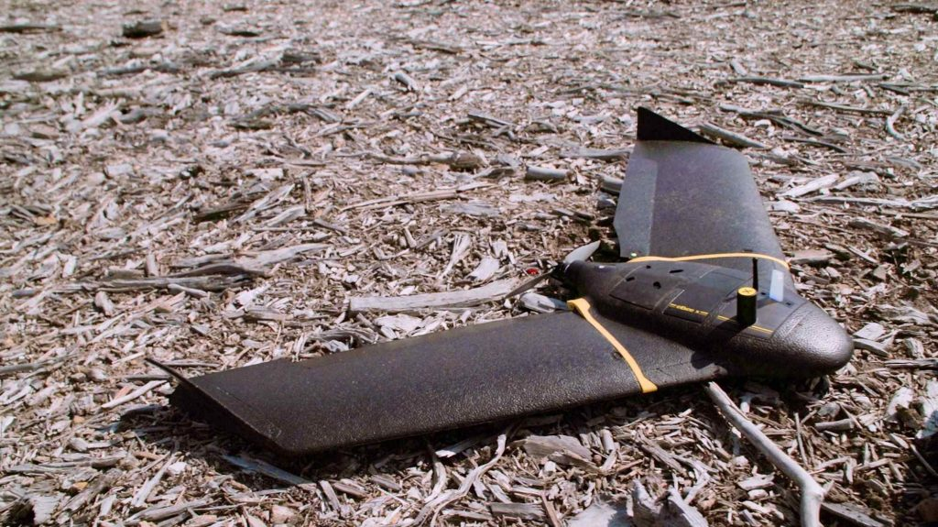
The downside of fixed-wing drones is that they tend to be more expensive compared to multi-rotor drones. They require a large, clear space to take off and land, just like airplanes. Some larger models also require specialized ground equipment to help them take off and land. In addition, fixed-wing drones can only fly forward, so they do not offer the same maneuverability as multi-rotor drones.

Single-rotor helicopter drones
Powerful and durable, single-rotor drones look similar in construction and design to actual helicopters, with only one rotor to provide power, plus a tail to control direction and stability. Combining the advantages of tiny multi-rotor drones and single-rotor drones, they are better suited to carry larger payloads and fly more efficiently than multi-rotors. Single-rotor devices typically use gas engines rather than batteries, which greatly increases their flight time.
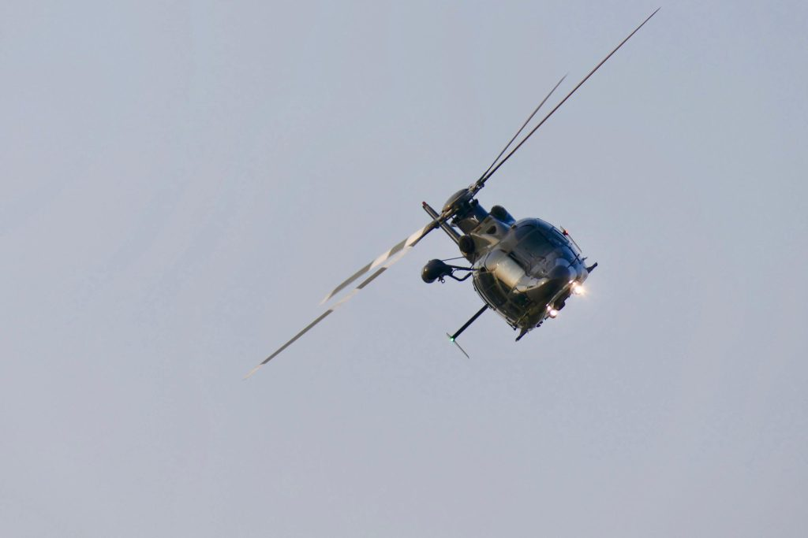
However, these drones tend to be larger and more complex than other types of UAVs. This means they are more expensive and more difficult to operate, and their larger blades can make them more dangerous.

Fixed-wing hybrid VTOL drones
As the latest drone technology to be introduced, fixed-wing hybrid VTOL drones refer to fixed-wing aircraft that have been modified to take off and land vertically. They combine the long-range and flight time of fixed-wing UAVs with the vertical takeoff capability of rotary-wing devices, eliminating the drawbacks of fixed-wing UAVs that require large spaces for takeoff and landing. They are designed for mapping, power line inspection, surveillance, agriculture, and rescue operations.
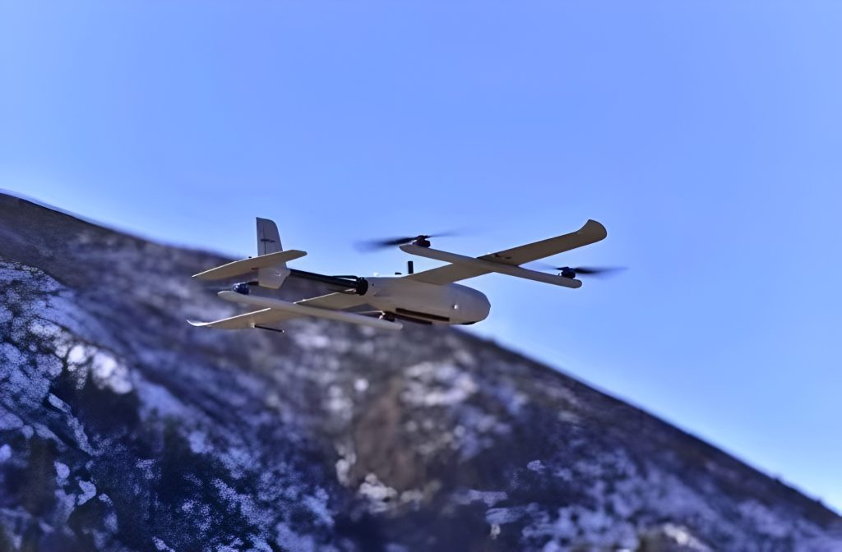
However, this VTOL drone tends to be unsuitable for beginners, and the more advanced technology puts it at the high end of the fixed-wing drone market in terms of cost.

Types of drones according to their sizes
Drones can be classified according to their size, from very small drones to large drones.
Size | Length | Propeller diameter | Weight | Use
Very small drones | 150mm (15cm, 6 inches) or less | 51mm (2 inches) or less | 200 grams (0.2kg, 0.44lbs) or less | Military surveillance
Small drones | Up to 300mm (12 inches) | 76-152mm (3-6 inches) | 200-1000 grams (0.44-2.2lbs) | - Indoor equipment inspections  - Recreation and photography
Medium drones | 300-1200mm (12 inches – 4 feet) | 150-640 mm (6-25 inches) | 1-20kg (2.2-44 pounds) | - Professional applications  - Amateur photography
Large drones | 120cm (4 feet) and up | 64 cm (25 inches) and up | 20kg (44 pounds) and up | - Enemy detection and combat capabilities  - Civil applications such as drone deliveries or filmmaking

Very small drones (Nano)
The size of these drones can be as small as an insect and easily fit in the palm of your hand, with dimensions between 1 and 50 cm. Because of their small size and wing design, nano drones can fly in very confined spaces and are not easily detected and are mainly used by spies to gather information on people and objects.
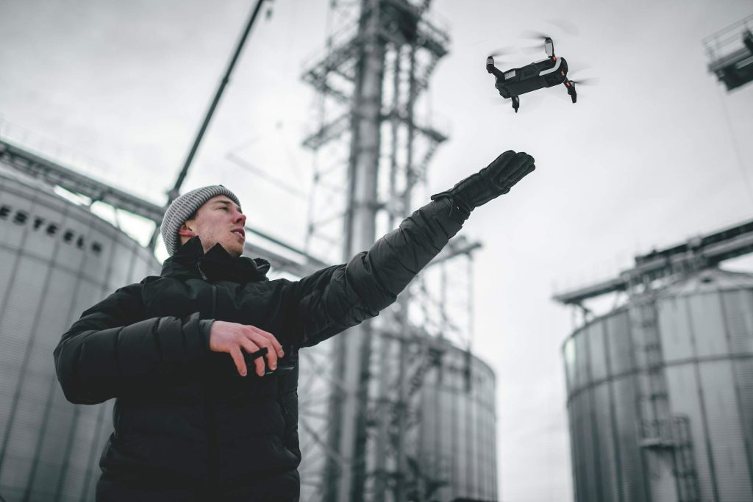

Small drones
Small drones they are slightly larger than micro drones, between 50 cm and 2 meters. The wings of these drones are usually fixed and can be easily lifted by the arm and thrown into the air. They can be used for indoor equipment inspections (prop guards, cages ......), but they are more often used outdoors for recreation and photography, such as traffic management.

Medium drones
Medium-sized drones are larger and heavier than smaller drones, with dimensions exceeding 2 meters and weighing up to 200 kilograms. They take two people to lift them, which are most often used for professional applications and amateur photography.
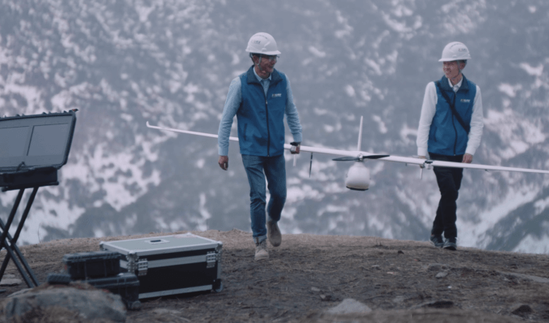

Large drones
Large drones are comparable in size to smaller aircraft and are used mainly for military purposes such as surveillance and strategy. With the most advanced technology, they are replacing fighter jets, allowing for rapid enemy detection and combat capabilities. They are also designed for civil applications such as drone deliveries or filmmaking.

Types of drones according to their payload capacity
How much weight a drone can carry will depend on the power of the motor and the lift generated by the propeller in standard weather conditions. Below, we will divide UAVs into four categories based on the weight of the payload they can carry.

Drone type | Weight | Payload capacity | Use
Featherweight drones | Less than 11 grams (0.011 kg) | 4 grams to 100 grams (0.004 to 0.1 kg) | Military surveillance
Lightweight drones | 200-1000 g (0.2-1 kg) | 150-270 g (0.15-0.27 kg) | Recreation and photography
Middleweight drones | 1-600 kg (2.20-1323 lb) | 400-1460 grams (0.4-1.46 kg) | - Professional applications  - Aerial photography
Heavy-lift drones | More than 160 kg | More than 1,000 kg | - Enemy detection and combat capabilities  - Civil applications such as drone deliveries or filmmaking

Featherweight drones
These are typically referred to as nanoscale drones, which weigh as little as 11 grams (0.011 kg) and can only carry payloads ranging from 4 grams to 100 grams (0.004 to 0.1 kg).

Lightweight drones
Lightweight drones refer to mini drones with an average weight of 200-1000 g (0.2-1 kg), and their payload capacity averages between 150-270 g (0.15-0.27 kg).

Middleweight drones
Here we are referring to medium-sized drones weighing between 1-600 kg (2.20-1323 lb). They are generally divided into two categories: commercial drones and military drones.
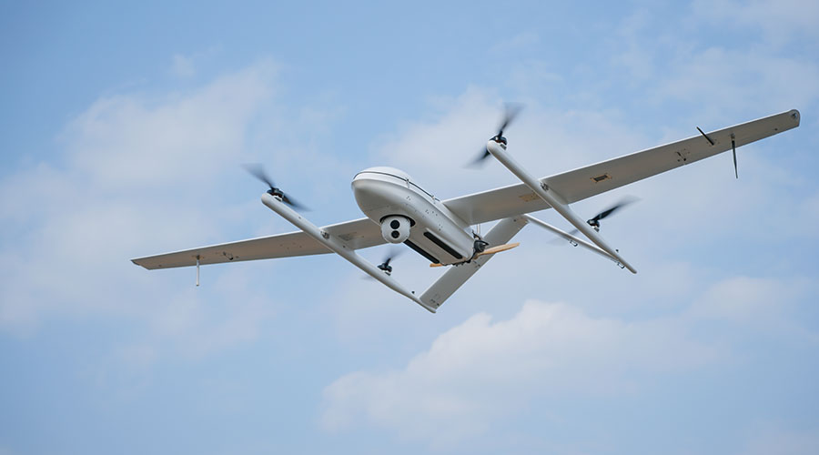
The payload capacity of consumer and commercial mid-weight drones averages between 400-1460 grams (0.4-1.46 kg). An example of a consumer/commercial drone is the JOUAV CW-15, which is capable of carrying an incredible 3 kg of different payloads!
Military mid-weight drones have payload capacities between 40 kg (88 lb) and 150 kg (331 lb).

Heavy lift drones
Heavy lift drones refer to large drones, mainly military drones, with a small percentage used for delivery and high-precision mapping. These drones weigh more than 160 kg, with some weighing more than 1,000 kg. Their payload capacity can reach 550 kg and above.
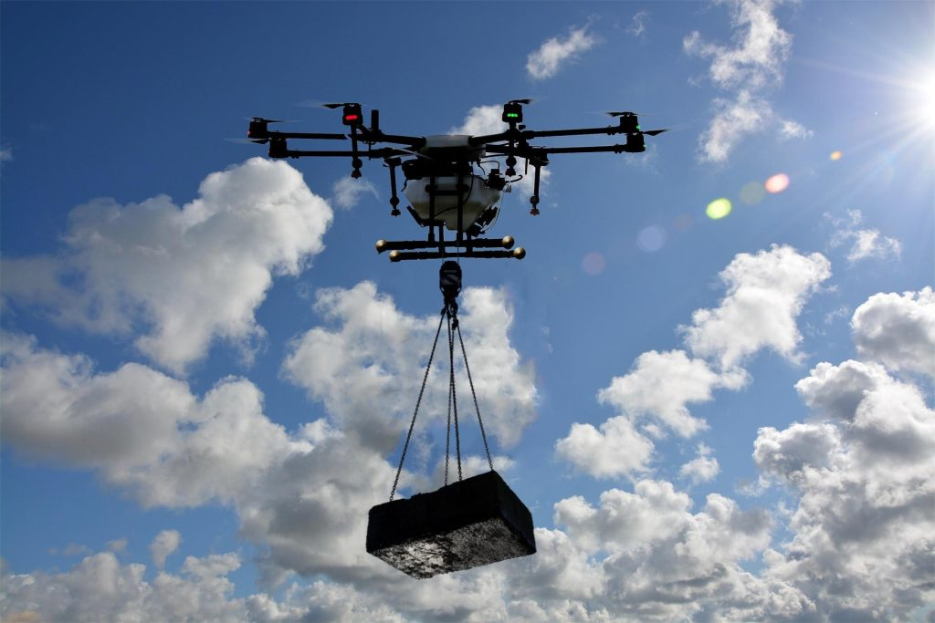

Types of drones according to drone range
According to the range, UAVs can be classified into very close range, close range, short range, mid-range, and long range.
Drone range | Flight distance | Flight time | Use
Very close-range drones | 5 km | 1 hour | Recreation
Close-range drones | up to 50 km | 1-6 hours | - Military surveillance  - Aerial photography
Short-range drones | up to 150 km | 8-12 hours | - Large-scale surveillance  - Mapping and surveying  - Utility inspection
Mid-range drones | 644 km | 24 hours | Military combat and surveillance
Long-range drones | More than 644 km | More than 24 hours | - Military surveillance and espionage  - Weather tracking  - Geographic mapping

Very close-range drones
Very close-range drones can fly within a range of 5 km from the controller, with an average flight time lasting 1 hour! These drones are mainly used for recreational purposes.

Close-range drones
Short-range drones can fly up to 50 km away from the controller and stay afloat in the air for 1-6 hours. Because they can fly very high, they are often used in military drones for surveillance.

Short-range drones
Short-range drones are drones that can fly up to 150 km away from the controller. With very powerful batteries, they can stay in the air for 8-12 hours and are usually used for combat as well as surveillance purposes.

Mid-range drones
These drones are capable of flying 400 miles (644 km). They can fly at altitudes of 12,000 to 30,000 feet for more than 24 hours. These are typically drones used for combat as well as surveillance.
As a drone with longest flight time and range, the JOUAV CW-30E has a control range of up to 200 km and a long flight time of up to 10 hours, which are widely been used in large-area surveillance and mapping.

Long-range drones
Long-range drones, also known as endurance drones, are technically and functionally superior to these other drones. It is estimated that they can travel well over 400 miles (644 km) (some reaching hundreds of thousands of square miles) without losing their signal. Although their use is primarily for military surveillance and espionage, they are also used by professionals to track weather patterns, geology, and geographic mapping.

Types of drones according to their power sources
In order to fly, a drone must have a power source, such as batteries or fuel. Based on the different power sources, drones can also be classified into different types.

Power source | Pros | Cons
Battery-powered drones | - Lightweight  - Ability to store decent amounts of energy  - High discharge rates | - Short lifespan  - Mistreat them and they can start a fire  - Use up energy fast
Gasoline-powered drones | - Potentially dangerous as they carry highly combustible fuels  - More noise than a battery-operated drone  - Large size | - No need for expensive battery backup and charging stations  - No need to wait for batteries to recharge  - Higher flight speed  - Easily carry heavier payloads  - Longer flight time  - Smooth and stable flight
Hydrogen fuel cell drones | - Renewable and environmentally friendly  - Resourceful  - Higher energy density than batteries  - Longer flight time  - Refuels in just minutes  - Works at low temperatures | - Generate a lot of heat  - Currently very poor in terms of efficiency
Solar drones | - Reduce operating costs  - Increase operating hours  - Lightweight | Limited flight time

Battery
The primary source of power for most drones is the battery. Three common types of drone batteries include lithium polymer (LiPo), nickel-metal hydride (NiMH), and nickel-cadmium (Nickel-Cadmium) batteries.

Gasoline
Generally, gasoline is used as fuel for large-sized drones because it is light and cheap. Gas powered drones have long flight times and large payload capacities.

Hydrogen
Hydrogen-powered drones are more efficient at high altitudes than many drones using internal combustion engines, which suffer more derogation due to lower air density. Smaller internal combustion engines exert peak fuel efficiency in only a narrow range of conditions with low noise, zero-emission, and great safety.
An example of a hydrogen-powered drone is the CW-25H, also known as DJ25, jointly developed by JOUAV and Doosan Innovation. It won the Wins CES 2022 Innovation Award and can carry a payload of up to 4kg.
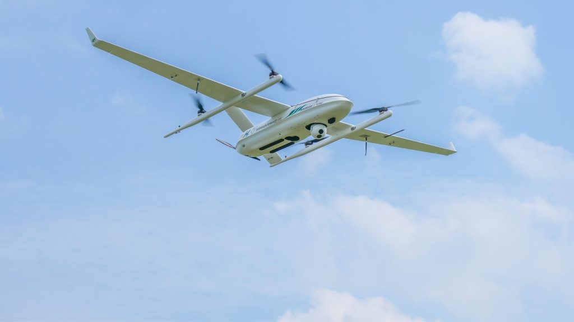

Solar
Solar-powered drones use the sun as a power source, converting sunlight into electricity in order to charge their batteries. This allows for long flights as long as the sun is available.

Types of drones according to their abilities & equipment

Toy drones
Toy drones it is conspicuous in the toy department of supermarkets, come in various sizes and shapes, with or without cameras, can be used indoors and sometimes outdoors, they can be controlled by remote control or smart phone depending on the model, he is generally moderately priced and is the ideal drone for beginners.
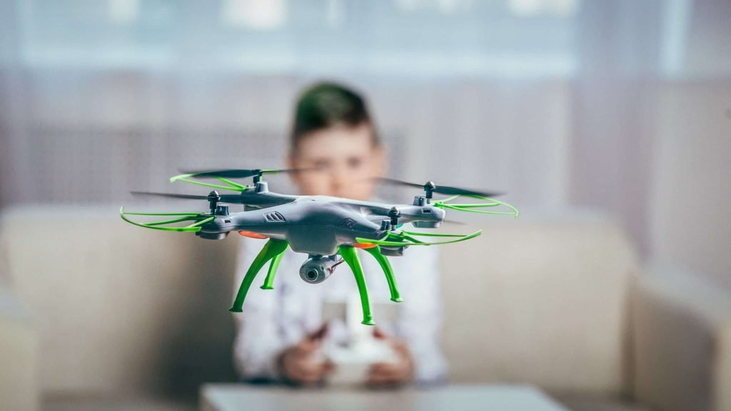

Photography/videographer drones
There are different kinds of drone models of cameras drones that can record photos or videos in HD, Full HD, or 4K, with the camera mounted on a 2-axis or 3-axis nacelle for perfect image stability.
They can be equipped with different features, GPS, people tracking, route programming, etc. Getting smaller and more sophisticated, it allows you to capture magnificent images from almost anywhere! Be aware, however, that the production and distribution of photos or videos taken in the airspace are strictly regulated.

Racing drones
Competitive drone or FPV racing is generally used on private and strictly regulated land and consists of obstacle courses at high speeds by flying a drone with virtual reality glasses, an activity that requires many hours of training to gain the agility and reflexes needed to control the drone. There are now a growing number of clubs that can legally engage in this hobby.
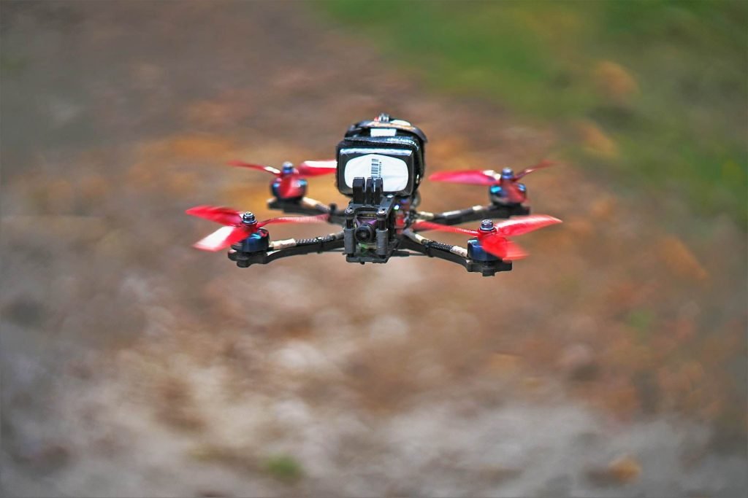

Ready-to-use (RTF) drones
RTF drones are drones that are available for users to assemble themselves. You can put all the parts you need in one kit, making it a fun experience as you build your drone!

GPS drones
These GPS drones are connected to satellites and use them as a means of plotting flight direction. They also can "return home" when their batteries are low.

Professional drones
Professional drones can be equipped with cameras or video cameras for all types of aerial photography. They can also be equipped with probes, sensors, or thermal imaging cameras for technical services such as mapping, surveillance, or others depending on the needs of the customer.
Professional drones are the only aircraft that can fly over built-up areas, restricted or prohibited areas, and conduct night flights, as long as the professional pilot has made a county declaration and obtained the required authorization.
They provide many services in the public and private sectors, inspection, control, or monitoring, whether it's beaches, traffic, buildings, or rooftops, these services are huge and continue to grow.

Military drones
Military drones, the origin of drones, are a completely different drone category from civilian drones. They are increasingly used in various conflicts, initially for surveillance and intelligence, but now they can be armed and become formidable weapons.
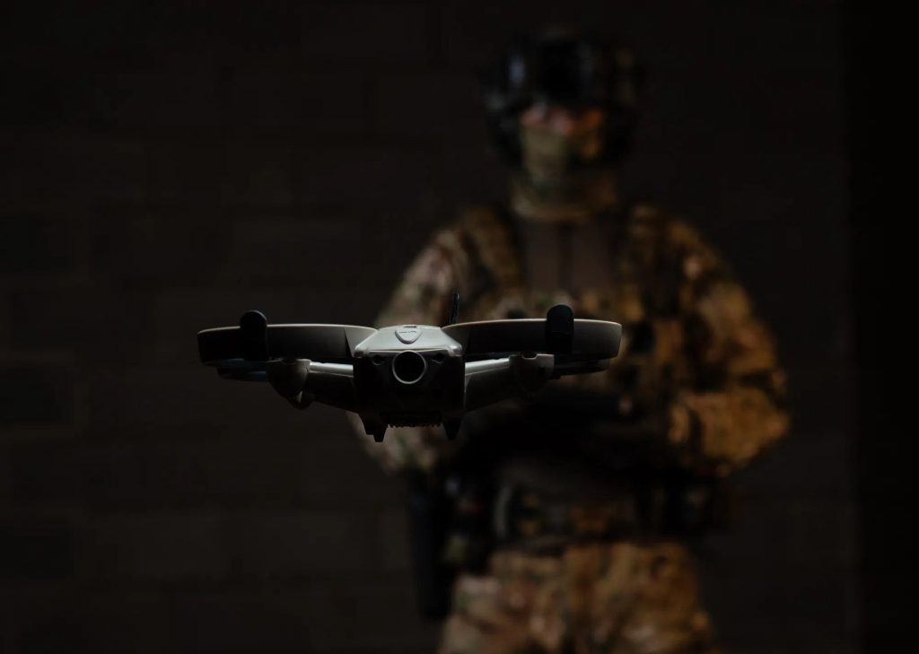

Delivery drones
Delivery drones are a new application of drones that are being tested by companies like Amazon. These UAVs types may soon become widely available to us in the future

Types of drones according to motors
According to the motor type, we can divide the drone types into brushed motor drones and brushless motor drones.
Drone motor | Pros | Cons
Brushed drone motors | - Inexpensive to make  - Can be made in a small package  - Favorable in extreme environments due to lack of electronics  - Replaceable brushes for extended life  - Two-wire control – control is simple; Brushless motors have 3 wires and require a speed controller to work  - No speed controller is required for fixed speed  - Less cost | - Uncomplicated wiring  - Low energy efficiency  - Commentators and brushes wear out more quickly
Brushless drone motors | - No brushes – lower maintenance and longer durability  - More efficient – less energy wasted as heat  - Better speed and torque due to the absence of brushes, because brush friction increases with speed  - Wider speed range  - Better heat dissipation due to the construction compared to brushed motors  - More cost-effective for high-speed/power operations | High cost

Brushed drone motors
Brushed motors are the type of motor present in most recreational drones. While they are indeed cheaper motors, they also require more maintenance than brushless motors.
The power of these motors is practically the same in all the models we could find, only the size varies (the larger the size, the more power). However, most of these motors are not in direct contact with the propeller.
The motor is connected to a pinion gear which turns a large gear which in turn drives the motor. This is called a "speed reducer" because due to these two gears we are reducing the maximum power the engine can give us. This will help us operate the drone and will extend its life because we will not be pushing the motor to its limits at any given time.

Brushless drone motors
The main feature of these motors is the absence of brushes in contact with the rotor. This keeps its maintenance to a minimum and its operation very effective and efficient. In addition, these motors have much higher power than brush/brushless motors (50-70 km/h compared to 150-200 km/h for brushless motors).

1.4 PRINCIPLES OF FLIGHT:
Four Forces of Flight: Lift, Weight, Thrust, and Drag
When your drone lifts off the ground and slices through the air, it’s all thanks to a balance between four key forces. Lift, weight, thrust, and drag are the building blocks of flight
Lift:
Lift is what your small UA’s wings or rotors create as air flows over them. Lift pushes against the UA’s weight as it ascends, letting you take off, stay level, and do all those awesome maneuvers.
Weight :
Weight is how gravity pulls down on the UA. It’s the force that needs to be countered by lift so your aircraft can stay up level and balanced.
Thrust:
Thrust is the push from your UA’s motors or engines that make the UA go forward. It helps you overcome drag and manage your speed, and steer where you want to go.
Drag:
Drag is the air pushing back against your UA’s motion. It counters thrust, affecting how fast and efficiently you can fly by creating resistance you need to overcome.
This drag is more noticeable at lower speeds or when climbing steeply, as the wings work harder.
It’s important to know that the more you speed up, induced drag eventually decreases because the UA’s aerodynamic design allows it to fly more efficiently.

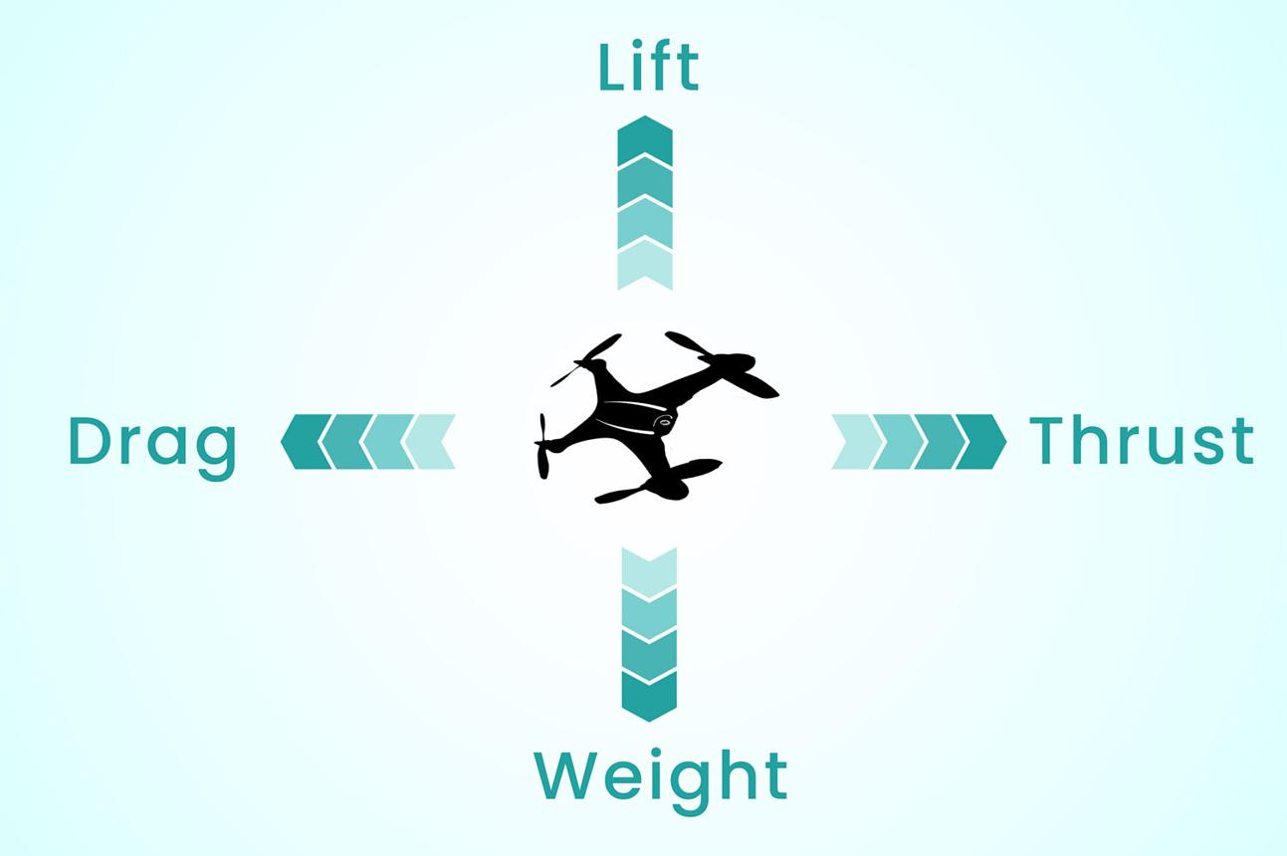
It's a Bird, It's a Plane, and It’s... a Drone!

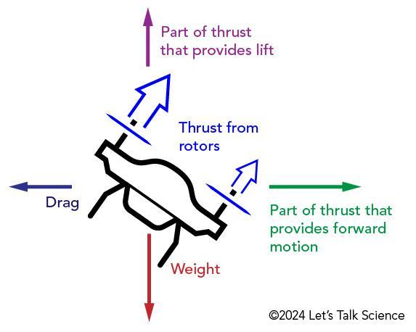

Welcome to the “The Beginner’s Guide to Drones” for programmers curious about exploring the world of unmanned aerial vehicles (UAVs). If you’re a coder from another field, this guide will walk you through the basics of drones, their components, and how to start programming them. Let’s dive in and see how your coding skills can take flight!
If you come from an engineering field, you might already know the basics of some of these topics; however you might still have use of the overview and can use the resources to get more specific knowledge.
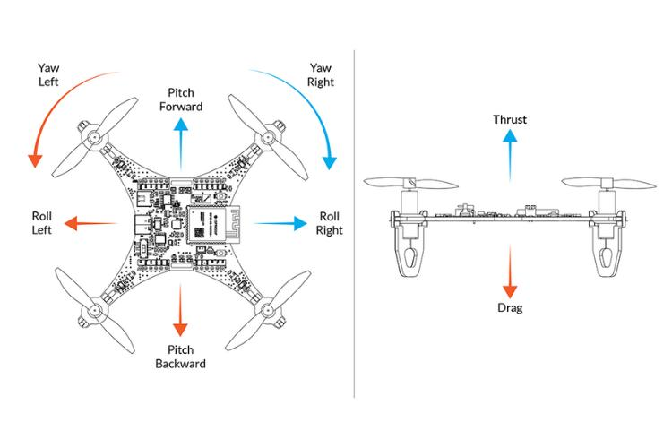
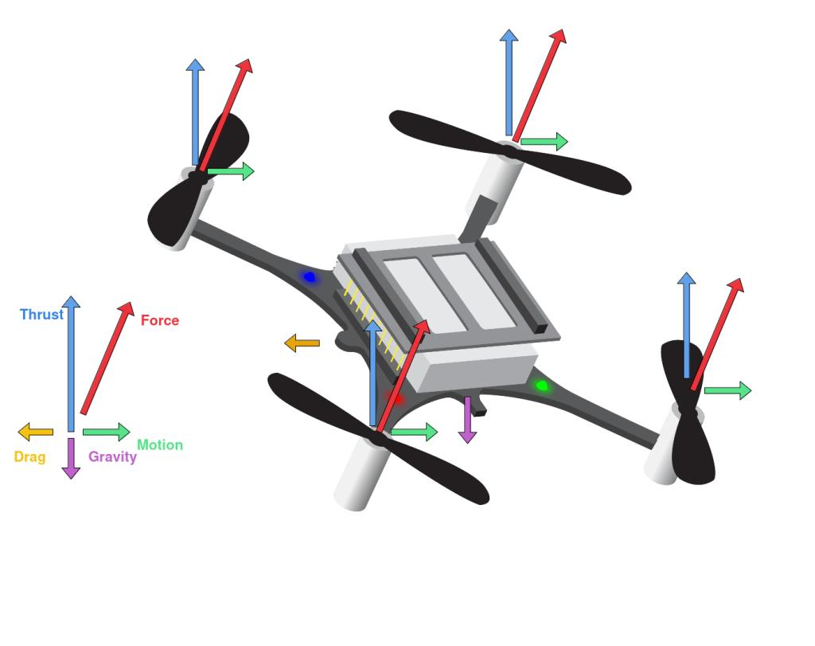

Computer-Aided Design, Multibody Dynamic Modeling, and Motion Control Analysis of a Quadcopter System for Delivery Applications

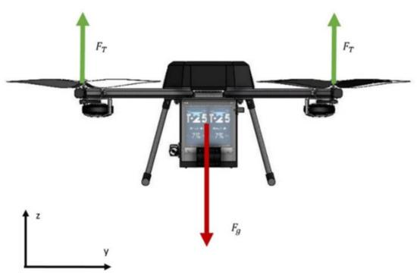
A drone remains airborne because of four aerodynamic forces.
Lift:
Lift is the upward force generated by the propellers.
Weight:
Weight is the downward force caused by gravity.
Thrust:
Thrust is the forward force generated by the motors.
Drag:
Drag is the air resistance opposing motion.

Flight Conditions
Hovering
Lift = Weight
Climbing
Lift > Weight
Descending
Lift < Weight
Forward Motion
Thrust > Drag
1.5 APPLICATIONS

AGRICULTURE:

- CROPCONSULTING
For generations farmers have walked their fields investigating crops manually for signs of stress or disease. This traditional, labour intensive method is time consuming and can be difficult when crop canopies thicken. With the drones, farmers are able to evaluate their crops at scale while simultaneously creating crop maps that help them manage crops and time better. The Phantom series of aircraft are highly portable, and boast industry leading flight times. Equipped with 12 megapixel cameras and up to 4K video they capture clear, detailed images that are essential for analysis and every Phantom is ready to fly out of the box. Aerial thermal imaging has also become an important tool for crop management. It is a non-invasive way to monitor nurseries and greenhouses and even detect plant diseases. Using the thermal imaging camera, all of this important data can be easily captured.
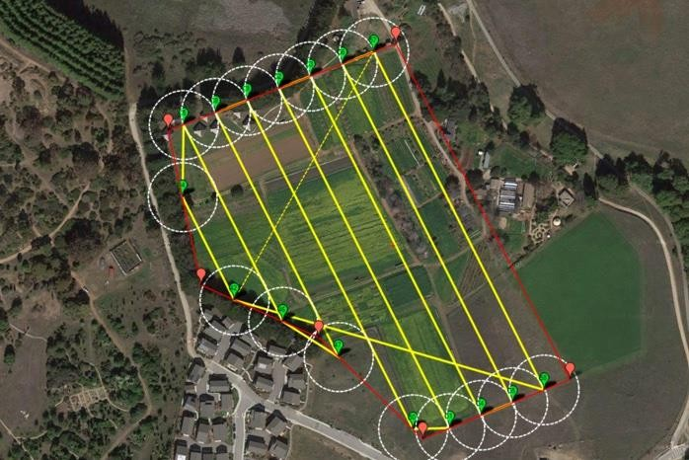

IRRIGATIONMANAGEMENT
Fresh water is one of our most precious resources, with farms worldwide constantly lookingtooptimizetheiruseofwater.Bothtoomuchandtoolittleaffectproductivity,meaning detailed tracking and monitoring is required. Large growers today often have many fields spread out across an entire region. These rely on the use of multiple irrigation pivots to water crops. Once crops such as corn begin reaching certain heights, mid-season inspections of the irrigation equipment that delivers much-needed water can become more difficult. With the drone’s thermal capabilities, irrigation and water pooling can be managed more efficiently. Powered by FLIR's industry leading thermal camera, the Inspire gives growers a detailed understanding of the state of their lands, giving them fundamental insights that lead to better decision making.

CROPINSPECTION

- Agronomists draw from a number of different sciences to address pressing issues, including producing food, creating healthier food, managing the environmental impact of agriculture, and extracting energy from plants. Whether they specialize in crop rotation, irrigation and drainage, plant breeding, plant physiology, soil classification, soil fertility, weed control, or insect and pest control, agronomists rely on a host of plant and environmental data. Airborne cameras can carry a powerful combination of infrared and visual cameras to create a view of crops that cannot be seen with the naked eye. This highlights differences between healthy and distressed plants and allows for rapid action where necessary. Drones can also survey a crop every week, every day, or even every hour. Combining this information into a time-lapse animation can highlight changes in the crop, revealing trouble spots or opportunities for better crop management. The M600 series heavy lifter platform gives agronomists a large payload, allowing them to deploy a wide range of third-party sensors and cameras from multi-spectral to hyperspectral and full frame. Powered by the new A3 flight controller, it can be upgraded with drone system for centimetre level hovering accuracy. Two additional satellite and IMU systems can also be added, creating a total of six layers of redundancy to ensure it flies with absolute reliability at all times. Its support of SDK allows it to be customized to simplify inspection, from standardized flight patterns to fully autonomous flight, and a base station can also be used to allow the control of up to 5 aircraft simultaneously to make inspecting a large farmland more efficient than previously possible.

- 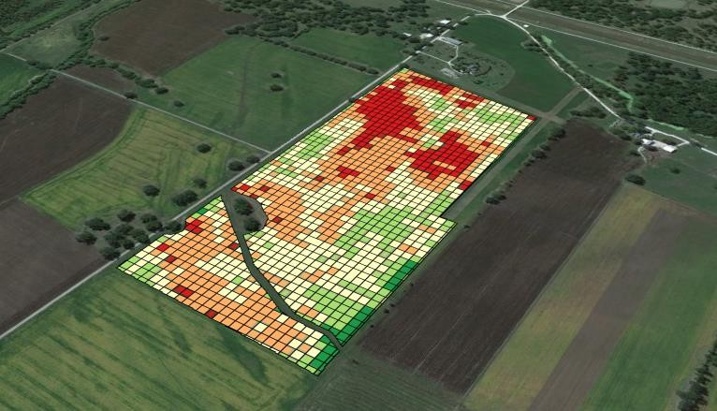

SPRAYING
- All farms rely on a number of plant protection and fertilization methods to maintain crop health and yields. For decades, farmers have either relied on labour-intensive manual spraying or hired crop dusters to spray fields too large for manual labour. Neither option is an ideal one as manual spraying is time intensive while crop dusters are cost heavy. The agricultural octocopter designed to increase efficiency and manageability in plant protection and fertilization. One single drone can carry 10kg of fluid and cover 10 acres (4 hectares) in a single flight. This is¬60 times faster than manual spraying. Industry standard ceramic nozzles come pre-installed and can be swapped out if necessary for different spray requirements. In addition to dust and corrosion proofing, drone is water-resistant so at the end of a spray it can be rinsed clean. Using drones modern farms have a new tool for spraying that saves on labour while maximizing coverage.
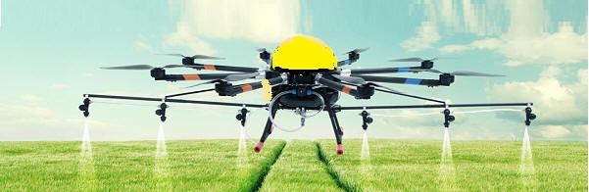

ENERGY
- SOLAR
The drone’s camera offers many advantages for rooftop solar panel inspectors and operators of massive solar farms. In addition to being able to clearly view temperature anomalies on acrisp the rmalimage,the drone can be used to scanin stalled solar panels during normal operation across large areas within a short time frame. This allows problem panels to be isolated quickly, ready for remedial action, keeping energy production at optimum levels. This will have a flight time of over 30 minutes, allowing for the inspection of large sites in a singleflight.Combinedwithcamerasprovidesolarenergyplantstheabilitytoinspectanarray of panels at speed. Instead of sending inspectors out into the plant to check individual panels on foot, a flight overhead recorded using 4K video provides the image clarity needed to carry out initial inspections. Inspectors then are only required to investigate problem areas, significantly increasing their efficiency and productivity.
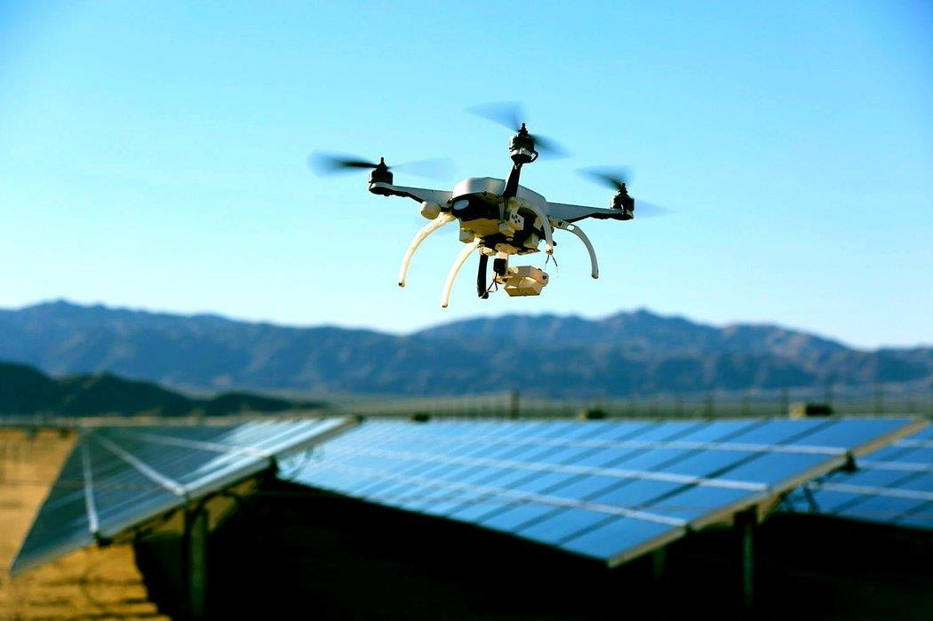

WIND
Windturbinespresentuniquechallengesformaintenanceinspections.Currentmethods involve hoisting staff to heights that present significant health and safety risks.

As a result, each inspection requires extensive downtime and meticulous planning before it can be carried out, reducing the overall efficiency of energy generation.
Conducting wind turbine inspections via UAVs is a significant improvement over existing methods.AUAVisabletoflypreciselyandaccuratelyincloseproximitytotheturbine,taking away the need to put people at risk. Advanced Sense and Avoid technologies found on the drones ensure that a sudden gust of wind or pilot error will not result in a collision.
Cameras, compatible with the drones produce high resolution imagery, 16 megapixel photos and 4K video, ideal for identifying fissures, cracks, or other indicators of structural stresses that may require repair. As all the data is stored on-board, it can be reviewed either at the point of inspection, or back at the office. These innovations allow inspection teams to increase their overall efficiency while reducing facility downtime.
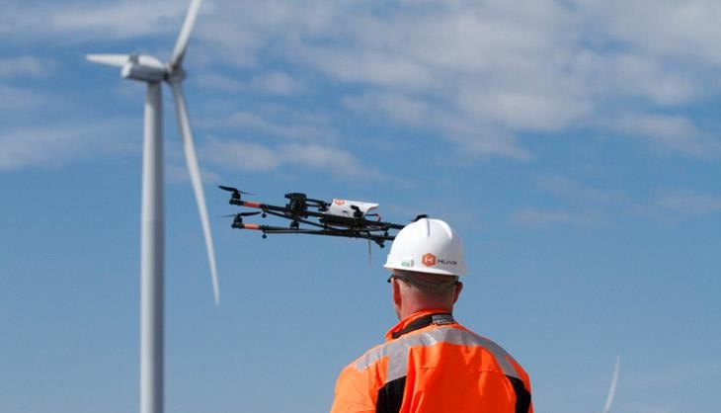

OIL &GAS
Safety and efficiency are paramount to modern energy refining facilities and inspectionsaremissioncriticaltomaintainingoperations.Traditionalinspectionmethodshave always been challenging as facilities can cover large areas with complex structural layouts. UAVs allow for even the largest facilities to be inspected quickly from the air. They provide simple, high altitude facility surveying as well as close proximity vertical inspection. More demandingscenarioscandrawwideportfolioofproductsspanningthethermalimagingsensor

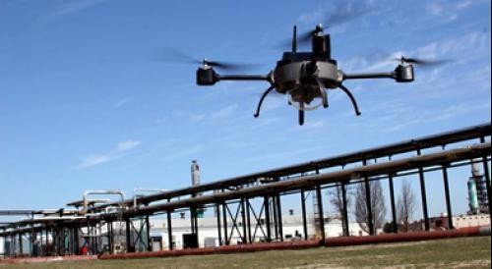
Created in collaboration with FLIR,the drone withit slarge Micro Four Thirds sensor,andhigh-efficiency platforms offering extended flight times of up to 30 minutes. However, and whichever technologies are applied, these systems allow teams to quickly identify structural weaknesses, scan for hot spots, identify gas leaks and much more, empowering them to make decisions quickly and move more efficiently to remedial actions.

POWERLINES
Power lines spanning vast distances are the circulatory system of modern power grids. They present unique maintenance challenges due to their geographical dispersion, as well as their height. Traditionally inspected by helicopter-based methods, they can be more easily and efficiently inspected using UAVs Inspection teams, equipped with drones Micro Four Thirds camera are able to begin aerial inspections mere moments after arriving on site. Capable of capturing 16 megapixel photos and 4K video the images these cameras capture is detailed enough for fine post-inspection analysis while the live feed will allow operators to see significant problems as they fly. The drone’s heavy lifter platform, combined with gimbal provides inspection teams with the capability to deploy heavy, large sensor cameras needed for more specialized work. Powered by the new A3 flight controller, it can be upgraded with D-RTK GNSS system for centimeter level hovering accuracy. Two additional satellite and IMU systems can also be added, creating a total of six layers of redundancy to ensure it flies with absolute reliability at all times. Its support of SDK allows it to be customized to simplify inspection, from standardized flight patterns to fully autonomous flight, and a base station can also be used to allow the control of up to 5 aircraft simultaneously to make inspecting different line segments simultaneously possible.

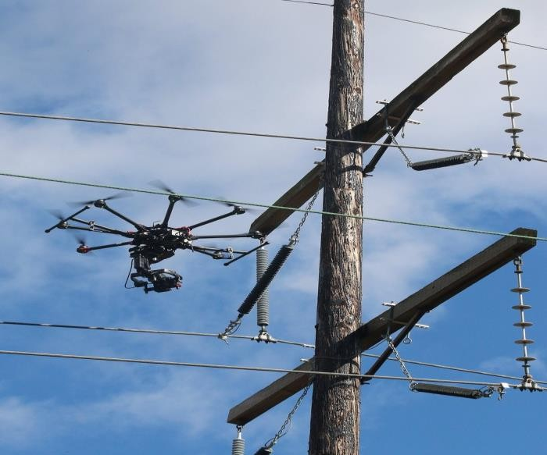

NUCLEAR
Nuclear power is one of the most efficient energy sources available today. However, nuclear facilities must be managed with stringent operational standards to ensure safety. Nuclear materials also present serious safety risks to inspection staff, strengthening the case for remote solutions. Using UAVs for inspections in these situations allows the work to be carried out more quicklythan traditional methods. The thermal camera is an integrated, ready to fly thermography solution to detect potential leaks or structural stresses not visible to the naked eye. The Inspire can also be flown with high resolution Micro Four Thirds cameras to create a flexible platform that meets the varied needs of different inspection teams and scenarios.

PUBLICSAFETY
- SEARCH&RESCUE
Search and Rescueisanactivitywherespeedcouldbemakeallthedifferenceinsaving a life. The thermal camera, developed in collaboration with thermal imaging experts FLIR, provides rescuers with an easily deployable aerial thermal imaging system that dramatically accelerates the search for missing people by highlighting thermal signatures and can even see throughfoliage.Pairedwiththedronesprovidesaclassleadingflighttimeof30minutes.This allowsittocovervastareasinasingleflight, searchingmoreareathananyonegroupofpeople would be capable of. Additionally, the drone provides access to the SDK, where dedicated search and rescue tools such as search patterns and full autopilot controls can be developed. Connected to the drone, the XT becomes a rapid launch aerial system.

Abletogofrompackedawaytointheairinjust3minutes,itisidealforurgent situations that need an eye in the sky as quickly as
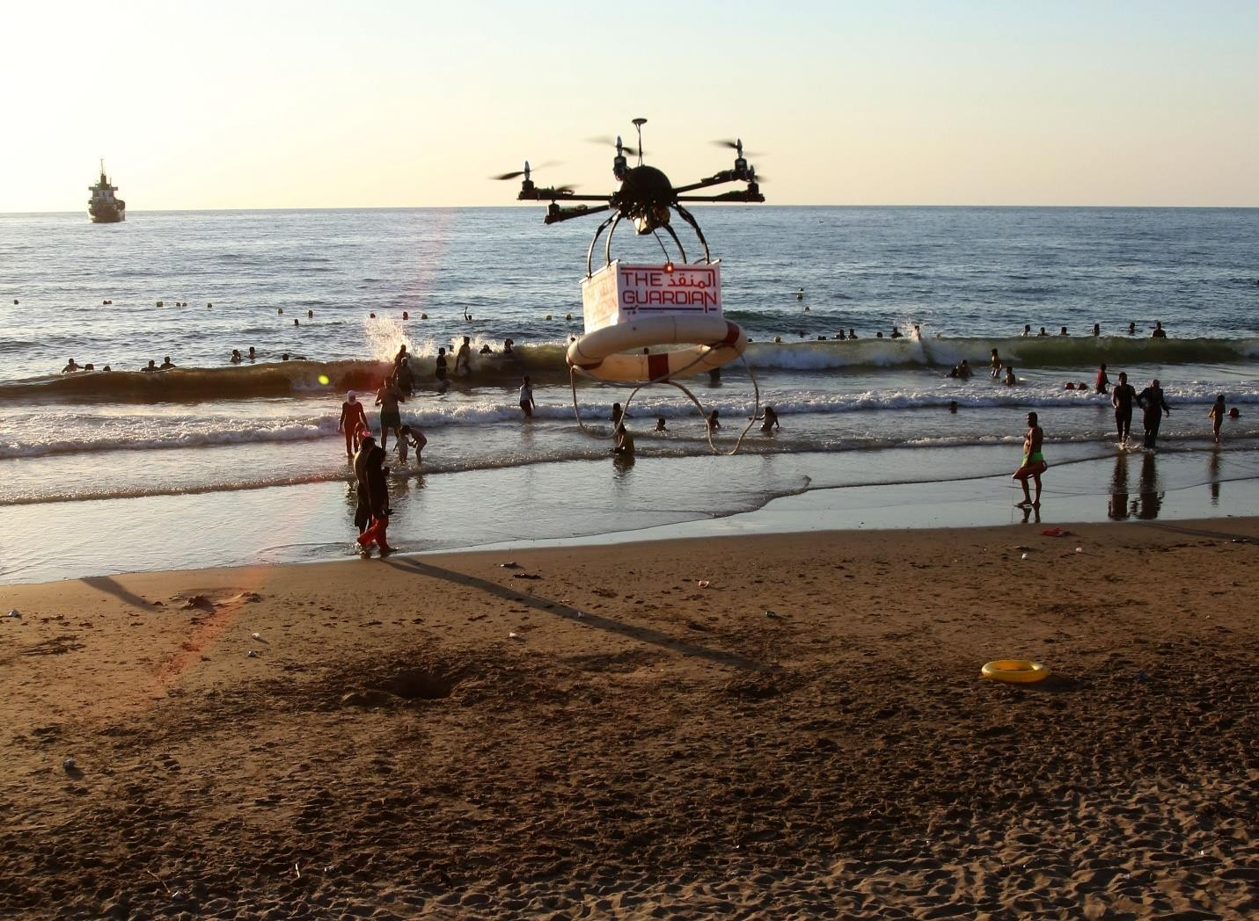
possible.

SURVEILLANCEANDCOMPLIANCE

USEOF FREQUENCIES
Drones use frequencies that may cause armful interference for a number of reasons.
These can be

    - Drones bought outside the European Union and used in Europe might well use frequencies intended for other use in Europe and interfere with that other usage.
    - Theuseofaparticularfrequencyrequiresalicensebecauseotherusersalsomakeuse of those frequencies. If no license is issued no planning has taken place and interference can occur.
    - The combination of emitting equipment might unintentionally cause interference.

    - Radio equipment in a drone may mal function.

    - The use of high transmission power may not be in accordance with regulations. In cases of reported interference, the NRA may start a surveillance to resolve the issue. Due to therelativeshortflighttimeofdrone’sinterferencemayhaveceasedtoexistwhenthereported interference case is investigated. In severe cases and reoccurrence of interference administrative fines may be issued.

ELECTRONICEQUIPMENT
National regulating authorities have the responsibility to verify the compliance of radio equipment to the R&TTE72 and the EMC directives. Within Europe, the national regulating authoritiescoordinatetheireffortswithinADCO.Basedonriskanalysisthenationalregulating authorities take samples of radio equipment entering the European market. If severe noncompliancetotheEMCorR&TTE/REDdirectivesisestablishedtheradioequipmentmay be taken off the national and European market. Since drones require radio equipment this procedure also applies to them.

GOVERNMENTUSAGE
In most countries the frequencies for drones used by the government is regulated differently than commercial or private use. The government, or parts of it like the Ministryof Defence, can make use of dedicated frequency bands which they use for their entrusted tasks. Additionally, a number of governmental organizations can make use of (military) satellites to command and control their drones even outside their own territories. This, however, does not mean that all ministries within a government have sufficient frequency spectrum available for drones. In most countries special legal arrangements exist to allow (parts of) the government toincreaseorreleasetheirrightsontheuseoffrequencies.Forinstance,intheNetherlandsthe government has to substantiate its claim for frequencies in a dedicated plan in which they describeindetailtheircurrentandfuturefrequencyneeds.IntheUKtheprincipaloffrequency spectrum pricing is used, in which the price for spectrum is used as an important mechanism to ensure that those resources are used efficiently by the users. In Europe drones used by the government, if they are not commercially of the shelf, do not need to comply with the EMC and R&TTE/RED directives. As mentioned before this does not mean that they can use any frequencytheylike or maycause harmful interference to other users with the same ore higher status.

MainController(MC)
Theheartoftheflight-controlsystem,thiscanbethoughtofasthe“brains”oftheUAV. It is an embedded computer that has custom software for controlling the aircraft, sometimes user-reprogrammable through a software development kit (SDK).
There may be a single circuit board (PCB) that includes the MC, gyros/sensors, electronic speed controllers (ESCs), and other core flight electronics.
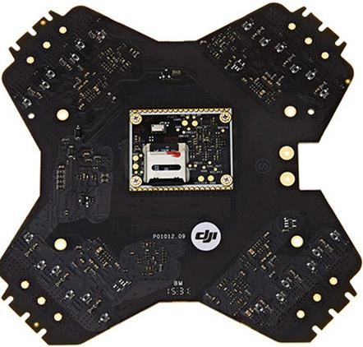
Fig1.0Main Controller

Gyros/Sensors
Forautonomy to work, the MCneedstotrackhowtheaircraftisflying.Toaccomplish this, some form of sensor arrayis provided. Generally, it will include accelerometers, inertial measurement units (IMUs), and gyros (measures angular rotational velocity), and may also work as GPS/compass.
Basically, these sensors tell the UAV how fast its acceleration is changing, in what direction, and whether it is right-side up. Those familiar with motorized gimbal camera stabilizers may recognize the same sensor technology being employed here as in gimbals.
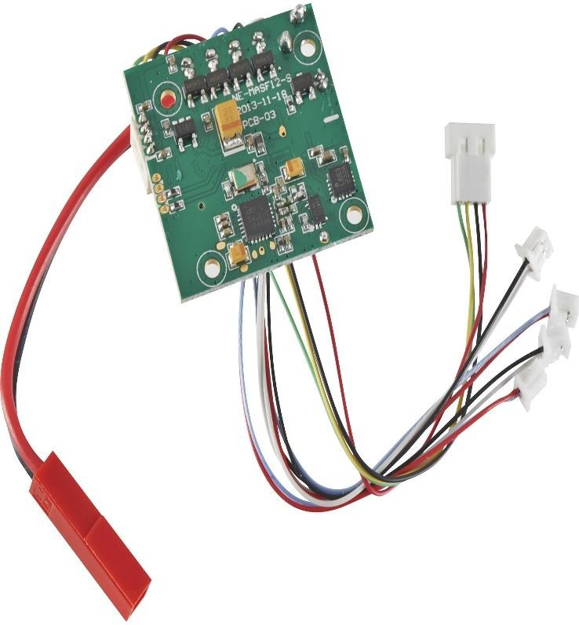
Fig1.1Gyros/Sensors

2

UNIT 2

2. COMPONENTS

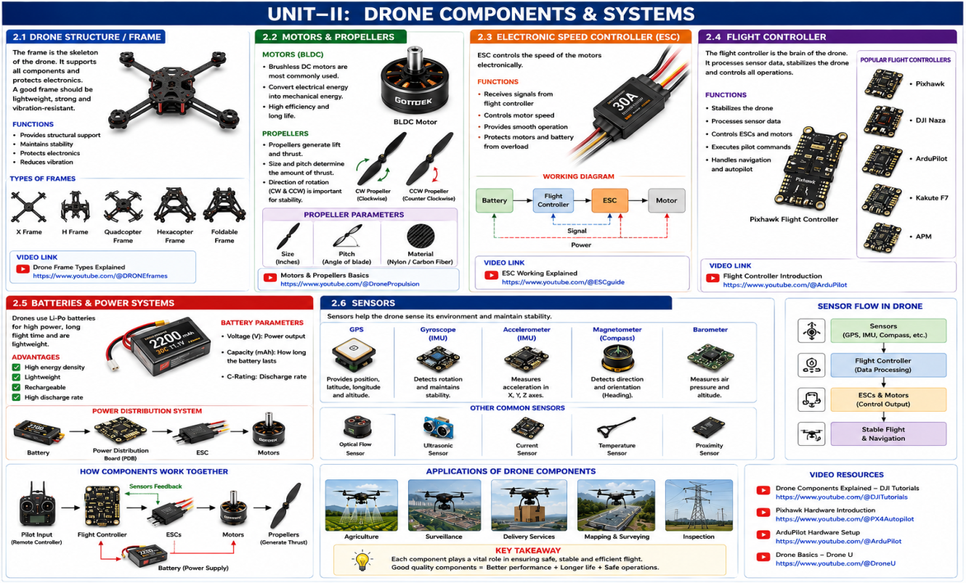
StandardProp:

While some drones like the DJI Phantom look more or less the same from any angle, there is a front and back.
• The “tractor” propeller are the props at the front of the quadcopter. These props pull the quadcopter through the air like a tractor.
• Most drone propellers are made of plastic and the better quality made of carbon fiber.
• You can also buy drone prop guards which you need especially if you are flying indoors or near people.
• This is also an area where we are seeing plenty of innovation. Better prop design will assist with giving a better flying experience and longer flight times.
• There is also some big innovation towards low noise uav props.
• Tip: Always good practice to inspect your props before flying and carry an extra set in case you notice some damage on a prop. Never fly with a damaged or bent prop.
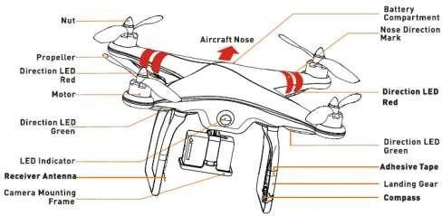
Fig2.0StandardProp

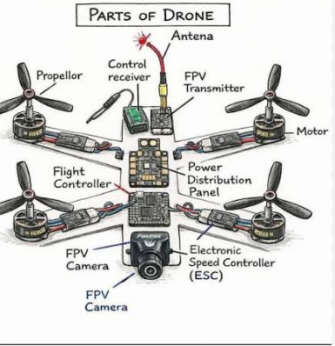

PUSHERPROP
    - The Pusher props are at the back and push the UAV forward hence the name “Pusher props”.Thesecontra-rotatingpropsexactlycanceloutmotortorquesduringstationarylevel flight. Opposite pitch gives downdraft. Again, can be made of plastic with the better pusher props made of carbon fiber. You can also purchase guards for the pusher props.
    - Tip: Same as for tractor props. Inspect be for each flight and carry as preset.

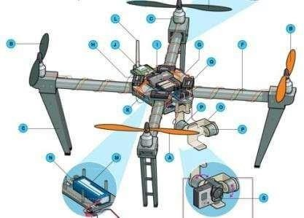

Fig2.1 Pusher Prop

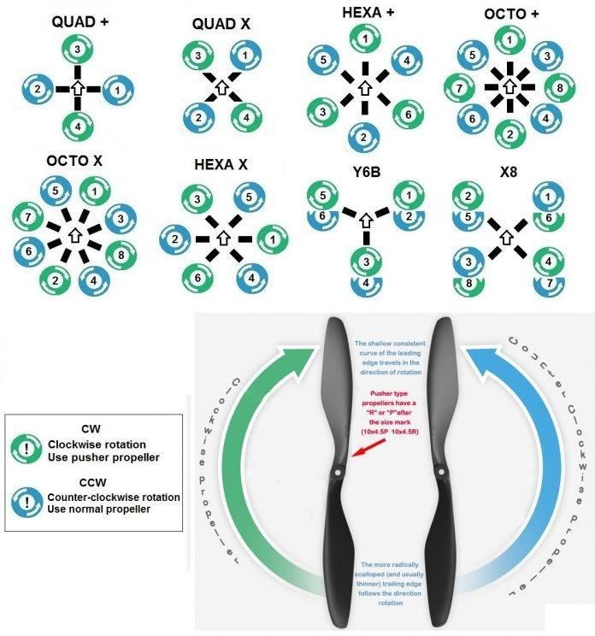

Fig2.2 Pusher Type Propellers

BRUSHLESSMOTORS
    - Practically all the latest drones use a brushless electric “out runner” type, which is more efficient, more reliable, and quieter than a brushed motor.
    - Motordesignisimportant.Moreefficientmotorssavebatterylifeandgivetheownermore flying time which is what every pilot wants. – DJI developed and patented a new curved magnet which fits perfectly around the motor allowing the motor to run more efficiently.
    - Tip: Examine the motors regularly. Make sure they are clean and free from dust. Get to know how your drone sounds. Listen to it. Most of the sound comes from the motors. If it doesn’t sound right, then examine your drone. Fly a couple of feet off the ground and close to you and see if one of the motor is failing. It’s not a bad option to have a spare motor or 2.

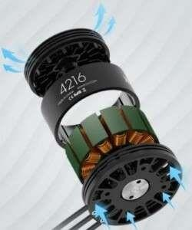
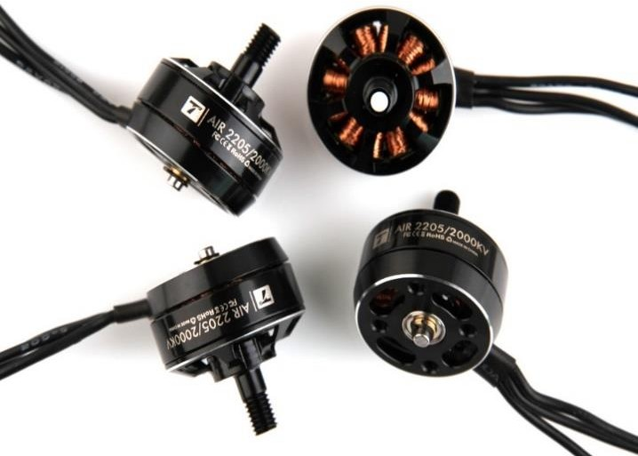
Fig2.3BrushlessMotors

MOTORMOUNT
    - Sometimes built into combination fittings with landing struts or can be part of the UAV frame.
    - Tip: Check the motor mounts and areas close to the motors for stress cracks. If you find stress cracks and your quad copter is under warranty, then you can send it back and have it fixed. Alternatively, the manufacturer may have some strengthened motor mounts.

    - Tip: When you first receive your new drone, it is also a good to examine areas around the motor mounts or where screws are used. Sometimes, screws can be wound in too tight and actually can crack the frame. It may be just hairline crack but these won’t fix themselves.

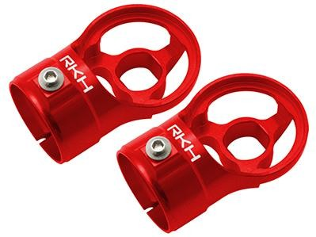

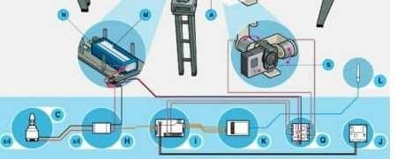
Fig2.4Motor Mount

LANDINGGEAR
    - Drones which need high ground clearance may adopt helicopter-style skids mounted directly to the body, while other drones which have no hanging payload may omit landing gear altogether.
    - Manyfixed wingdrones which cover large distances such as the Sense flyeBee, Trimble UX5 or the 3DR Aero-M don’t have landing gear and land perfectly fine on their belly.

    - Mostdronehasafixedlandinggear.However,thebestdroneswillhaveretractablelanding gear giving a full 360-degree view.
Retractable LandingGear Drones

    - DJI–SpreadingWingsS1000+,Inspire1

    - Walkera– Voyager 3, Scout x4, QR X900

    - Tip:Examineyourlandinggearandespeciallyifyou’vehadabitofaroughlanding.This protects the drone, expensive camera or sensors.
    - Tip: If you can and it suits your needs, buy a drone which has retractable landing gear. Then you don’t have to worry about the legs getting in the way of a great photo or video shot.Withretractablelandinggear,keepitcleanandfreefromdustanddirt.Inthatwaythe landing gear doesn’t seize up.

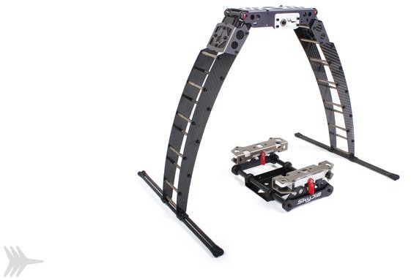
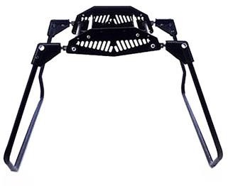

Fig2.5Landing Gear

BOOM
    - Shorter booms increase manoeuvrability, while longer booms increase stability. Booms mustbetoughtoholdupinacrashwhileinterferingwithpropdowndraftaslittleaspossible. In many drones the boom is part of the main body. Other drone has a definite boom as a separate part.
    - Tip:Examineandinsurethattheboomhasnotbecomebentasthiswouldaffecttheflying capabilities.

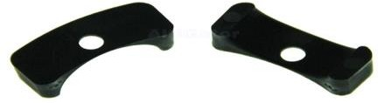

Fig2.6Boom

MAINDRONEBODYPART
    - Thisisthecentralhubfromwhichboomsradiatelikespokesonawheel.Ithousesbattery, main boards, processors avionics, cameras, and sensors.
    - Tip:Mostdrones are not water proofso itisvital thattheinternalcomponentsofthemain body do not get wet.
    - Ahardlandingmaynotbreakthebodyofthedronebuttheshockcoulddamagetheinternal drone components in the main body.

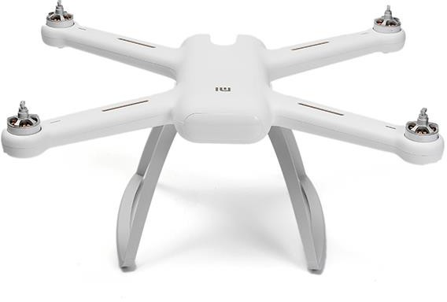

Fig 2.7MainDroneBodyPart

ELECTRONIC SPEED CONTROLLERS (ECS)
    - Electronic Speed Controllers are an essential component of modern quadcopters (and all multicolor) which offer high power, high frequency, high resolution 3- phase AC power to the motors in an extremely compact miniature package.
An electronic speed controller or ESC is an electronic circuit with the purpose to vary an electricmotor’sspeed,itsdirectionandpossiblyalsotoactasadynamicbrake. Itconverts DC battery power into 3-phase AC for driving brushless motors.
    - ThelatestESCinnovation wasontheDJIInspire1whichusesnewsinusoidaldriveESC which replace the squarer wave drive of traditional ESCs. The Inspire 1 goes further by using closed loop torque control and distinct functional redundancy which adds extra efficiency and reliability to the motors.
    - Tip: The ESC are inside the main frame of the drone and most drone owners won’t need to do anything with these. However, companies suchasDJI,3D Rand Parrot develop drones which can be customized. What allows these drones to be customized is a Special Development Kit (SDK). With the SDK, then you could reprogram the electronic speed controllers and many other drone components.

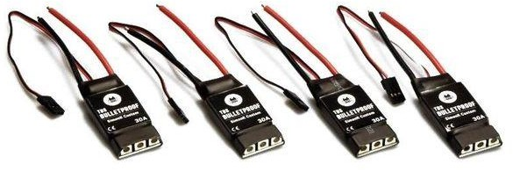

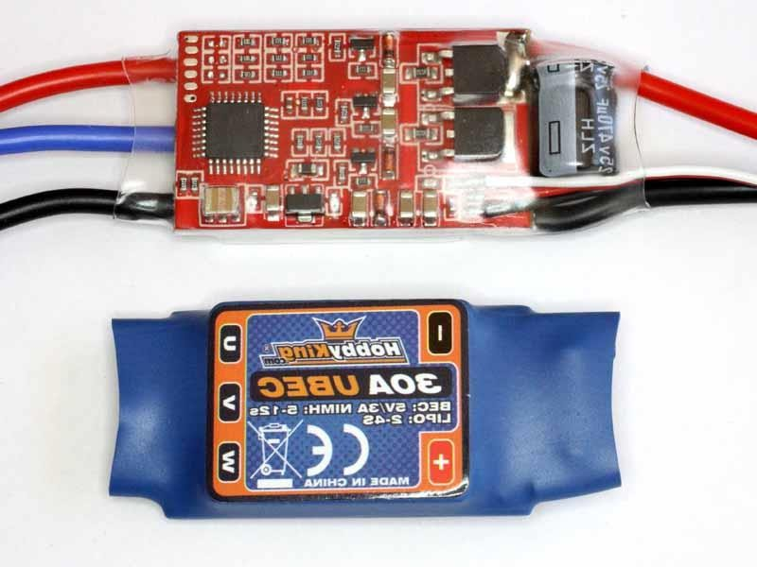

Fig2.8ElectronicSpeedControllers

FLIGHT CONTROLLER
    - Theflightcontroller:–interpretsinputfromreceiver, GPSmodule, batterymonitor, IMU andotheron-boardsensors–Regulatesmotorspeeds, viaESCs, toprovidesteering, aswell astriggeringcamerasorotherpayloads.–Controlsautopilot, waypoints, followme, failsafe and many other autonomous functions. It’s central to the whole functioning of your UAV.
    - Tip: Most owner won’t need to do anything or modify the flight controller by reprogramming. If you needed to create a customized solution, then a drone with SDK as mentioned about would allow this.
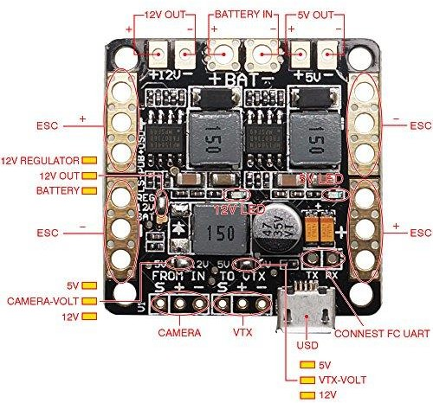

Fig2.9FlightController

GPSMODULE

    - GPS stands for Global Positioning System. It is an American standard which provides locationandtimeinformationinallweatherconditions,anywhereonorneartheEarthwhere there is an unobstructed line of sight to four or more GPS satellites.
    - OftencombinesGPSreceiverandmagnetometertoprovidelatitude,longitude,elevation, and compass heading from a single device.

    - GPS is an important requirement for waypoint navigation and many other autonomous flight modes. Without GPS drones would have very limited uses. Along with FPV, drones can navigate long distances and be used for exiting applications such as LIDAR and photogrammetry.
    - Note: Some of the latest drones have added Glonass, which is the Russian equivalent of GPS. This means your drone is almost guaranteed to find many satellites to get its positioning from. With both systems you can fly more accurately and also can fly safer as you know you won’t lose satellite connection.
    - Tip: Most drones allow you to program in a failsafe home point. This allowsthe drone to fly back to a point if it loses connection to your remote controller. Most drones have a minimumrequirementofsatellitesbeforethehomepointcanbeset.Butalwayssetahome point. When buying a drone, keep an eye out for drones which come with both GPS and Glonass.
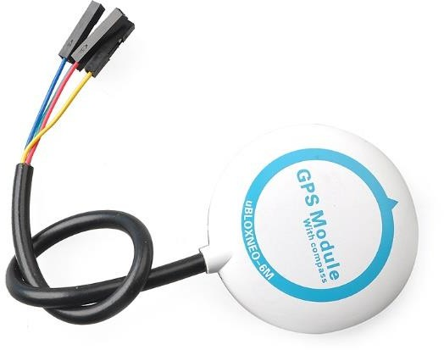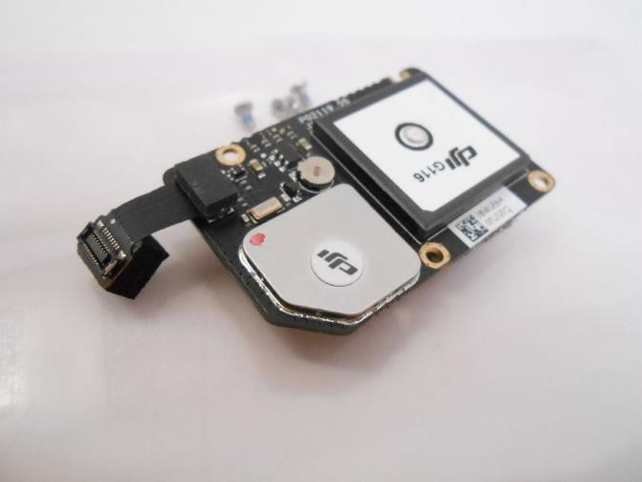

Fig2.10GPSModule

RECEIVER

    - Often a standard r/c radio receiver unit. The minimum number of channels needed to control a quad is 4, but 5 is usually recommended. There are many manufacturers of receivers on the market if you are building your own drone.

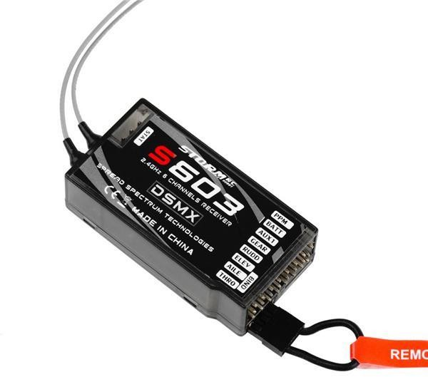

Fig2.11Receiver

ANTENNA

    - Dependingonyourreceiver, itmaybealoose wirewhiporhelical“rubberducky”type.

    - Tip:Prettyeasytoupgrade.Circularlypolarizedcloverleafantennagivesyoufurthervideo signal distance and improves thevideo stability. Averygood antenna stops theproblem of the multi-path effect and also blind angle.
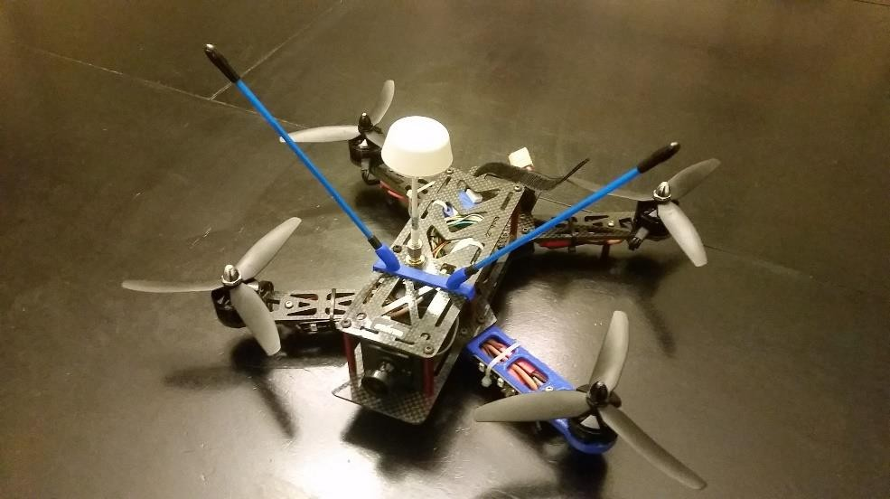

Fig2.12Antenna

BATTERY
    - Lithiumpolymer(LiPo)batteriesofferthebestcombinationofenergy density,power density, and lifetime on the market.
    - Tip: It’s always great to carry a spare battery or 2. Read and follow the instructions forcharging and storing your battery to make sure it lasts a long time.
    - Everysooften isalwaysgood tofullydischargeandrechargeyour battery.

    - Checktomakesureyourbatterydoesn’t overheat.

    - Allbatteriesaredangerouswhenarephysicallydamagedsoneverinstalladamagedbattery into your drone.
    - Alsonever tryto rechargeabatterythat hasphysical damage.

    - Tip:Makesureyoudronecomponentsareingoodphysicalconditions.Alwaysthink safety.
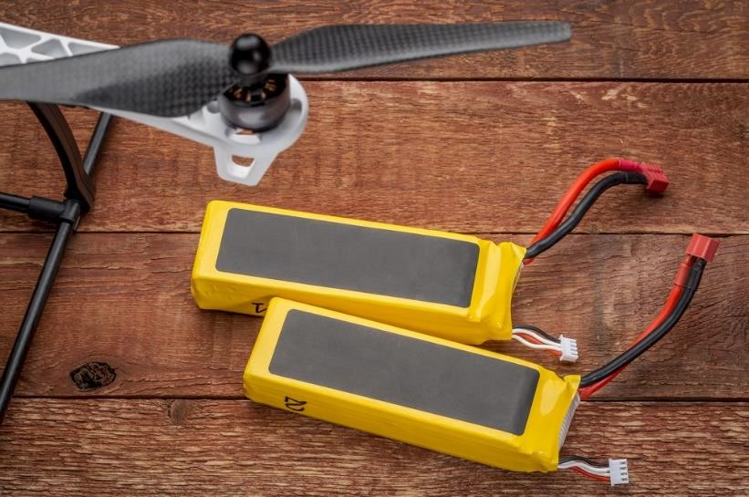

Fig2.13Battery

BATTERYMONITOR

    - Provides in-flight power level monitoring to flight controller. Your battery is critical to flyingsafely. If youflytofarout and yourquadcopterrunsoutofbattery thenitwilleither make an emergency landing or will crash.
    - Tip: Know your drones flying time, battery levels and where to read these levels. Dont push the boundaries of flying on low battery power.

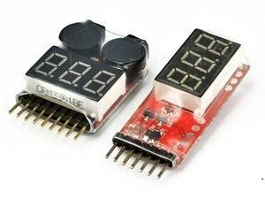
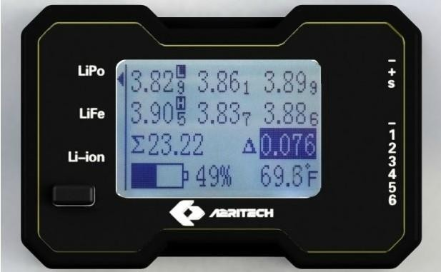

Fig2.14BatteryMonitor

GIMBAL

    - The drone gimbal is the pivoting mount that rotates about the x, y, and z axes to provide stabilization and pointing of cameras or other sensors.
    - Tip: If you don’t have a great gimbal, then it doesn’t matterhow good the camera is. The gimbal is all important to taking great photo and video.
    - Tip: If you are having problem with jello effect, which is caused by vibration from the drone getting to the camera, then look at installing or changing the gimbal dampers. This change alone can make a big difference.

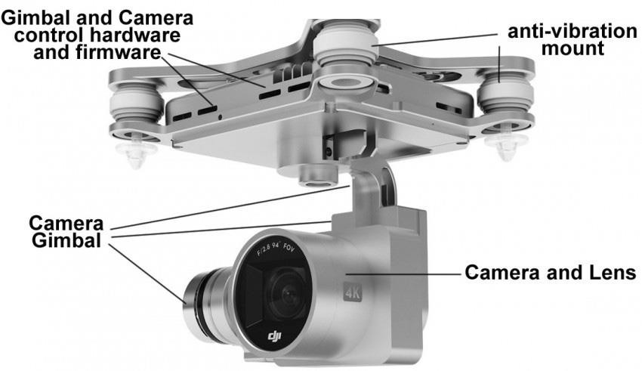
Fig2.15Gimbal

GIMBALMOTOR

    - BrushlessDCmotorscanbeusedfordirectdriveangularpositioning,too,whichrequires specially-wound coils and dedicated control circuitry that have only recently become commercially available.
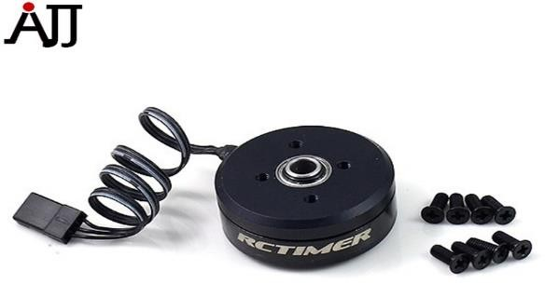

Fig2.16 Gimbal Motor

GIMBALCONTROLLERUNIT
    - Allows control of direct-drive brushless gimbal motors as if they were standard hobby servos.

CAMERA AND SENSORS
    - GoPro or other compact high definition video unit with on-board storage. Real-time streamingispossibleonthelatestdronessuchastheDJIMavicPro,thenewPhantom4Pro andthetopprofessionalInspire2filmingquadcopter.Withthewrongcameraonyourdrone, you will never be able to take professional videos or photos. Some of the problems are rolling shutter, jello and barrel effect.
    - Manydronemanufacturers produced gimbals which arecompatible with the GoPro Hero camera range. The latest drone from 3DR called the SOLO was designed specifically with the GoPro Hero cameras in mind.
    - However, this year we also seen a move towards all in one drones with come with an integrated gimbal and camera. The camera is specifically designed for aerial filming and photography.

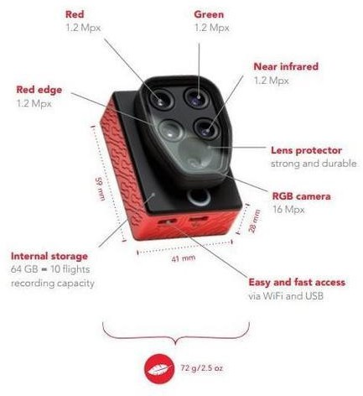
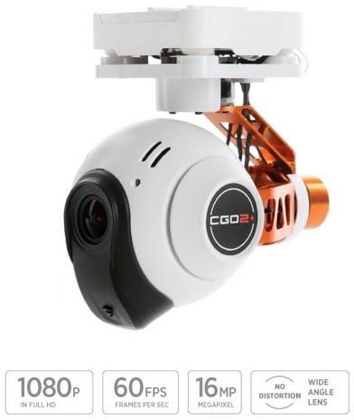

Fig2.17Camera and Sensors

